450 E. Main Street
John Day, OR 97845
www.cityofjohnday.com
Tel: (541) 575-0028
Fax: (541) 575-3668
Conditional Use Permit (Type III) CUP-21-02

STAFF REPORT

Date Submitted: March 31, 2021

Agenda Date Requested: April 7, 2021

To: John Day Planning Commission

From: Daisy Goebel
Associate City Planner

Subject: Conditional Use Permit (Type III Quasi-Judicial)

Location: Address
Map: 13S31E26AB Tax Lot: 8102

Type of Action Requested: Conditional Use Permit for RV Accessory Structure

[ ] Resolution | [ ] Ordinance
[ X ] Formal Action | [ ] Report Only

----------------------------------------------------------------------------------------------------------
- BACKGROUND

Cody Weaver, the owner of record for the property located at 316 Ferguson Rd., has requested a Conditional Use Permit to allow an increase on the permitted height for a proposed accessory structure to be used for recreational vehicle storage. The property is zoned Residential Limited (RL) which allows the property owner to construct an accessory structure with an approved use no taller than 14 ft. in height and no larger than 1,000 sq. ft. in area. The proposed accessory structure will be 15’ 7” in order to accommodate an RV, so the request must be approved by the city Planning Commission as a conditional use permit.

- APPLICABLE CRITERIA

The City of John Day Development Code (the Code) governs the procedure for reviewing Conditional Use Permits. All land use and development permit applications and approvals, except building permits, shall be decided by using the procedures contained in Chapter 5-4 of the Code. The procedure “type” assigned to each application governs the decision-making process for that permit or approval.

An application for a new conditional use shall be processed as a Type III procedure, per Section 5-4.1.040 of the Code. The application shall meet submission requirements in Section 5-4.4.030, and the approval criteria contained in Section 5-4.4.040.

Staff has reviewed the application pursuant to the Code and the requirements for a conditional use permit. The application was deemed technically complete (ready for review) on March 9, 2021. The City must make a final decision, including a final city council decision on any appeal, within 120 days, or by July 7, 2021.

- PUBLIC NOTIFICATION

The City of John Day mailed public hearing notices to the applicant and property owners within 100-feet of the subject site on March, 12, 2021. Notice of the hearing was printed in The Blue Mountain Eagle on March 24, 2021 as required by the Code.

- BURDEN OF PROOF

The applicant has the burden of demonstrating that the proposal meets all applicable Code requirements. The applicant is also responsible for complying with building code requirements and applicable state or federal requirements. It is the Planning Commission’s responsibility to interpret the Code based on findings of fact.

- PLANNING COMMISSION AND CITY COUNCIL CONSIDERATIONS

The Planning Commission’s review must focus on the relevant code criteria and follow the public hearing requirements for a Type III procedure under section 5-4.1.040.

- STAFF RECOMMENDATION

Staff recommends that the Planning Commission approve the request for conditional use permit CUP 21-02. It is the applicant’s responsibility to demonstrate compliance with the conditions of approval.

- APPROVAL CRITERIA AND FINDINGS

John Day Development Code Section 5-4.4.040 Conditional Use Permits – Criteria, Standards and Conditions of Approval contains the applicable approval criteria for the conditional use permit application. The Planning Commission’s evaluation of the project must focus on the relevant code criteria under Section 5-4.4.040 and follow the public hearing procedures for Type III (quasi-judicial) review under Section 5-4.1.040.

The applicable code criteria are provided below in italics typeface; staff’s findings follow each code provision in regular typeface. The findings, which are based on information submitted by the applicant, are preliminary. The plans, exhibits, and narrative submitted by the applicant and used in making the findings are attached to this report and include:

- Application (Exhibit A)
- Site Diagrams (Exhibit B)

All of the above documents are hereby incorporated and made part of the public record.

The application and staff report findings may be modified based on factual information entered into the public hearing record before the close of the record. Members of the public who have questions about the proposal or who would like to submit oral or written testimony are encouraged to appear at the public hearing or provide written testimony before the close of the hearing. Testimony should respond directly to the following criteria.

5-4.4.040 Conditional Use Permits – Criteria, Standards and Conditions of Approval

The City shall approve, approve with conditions, or deny an application for a conditional use or to enlarge or alter a conditional use based on findings of fact with respect to each of the standards and criteria in A-C.

- Use Criteria
  - The site size, dimensions, location, topography and access are adequate for the needs of the proposed use, considering the proposed building mass, parking, traffic, noise, vibration, exhaust/emissions, light glare, erosion, odor, dust, visibility, safety, and aesthetic considerations.

Findings: The size of the property is .19 acres. The size, dimensions, location, topography and access are adequate for the proposed use.

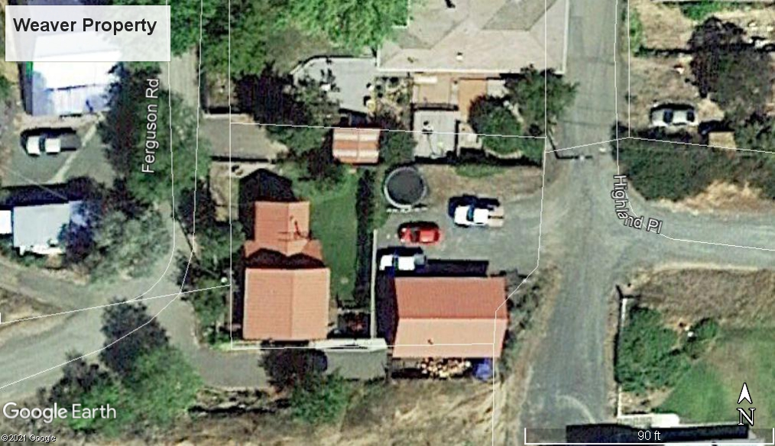

  - The negative impacts of the proposed use on adjacent properties and on the public can be mitigated through application of other code standards, or other reasonable conditions of approval.

Findings: Adjacent property owners were notified of the application, and no public comments were received concerning potential negative impacts of the proposal. Staff does not anticipate the 1’ 7” height will have negative impacts on adjacent properties.

  - All required public facilities have adequate capacity or are to be improved to serve the proposal, consistent with City standards.

Findings: The proposal does not include public utility hookups, and the conditional use will not impact the current use or capacity of public facilities.

  - A conditional use permit shall not allow a use that is prohibited or not expressly allowed under Article 5-2; nor shall a conditional use permit grant a variance without a variance application being reviewed with the conditional use application.

Findings: The proposed structure is consistent with Article 5-2.

B. Site Design Standards. The Site Design Review approval criteria (Section 5-4.2.060) shall be met. The Planning Official may waive the application requirements for the Site Design Review upon determining that the Conditional Use Permit application provides sufficient information to evaluate the proposal.

Findings: The CUP application provides sufficient information to evaluate the proposal.

C. Conditions of Approval. The City may impose conditions that are found necessary to ensure that the uses is compatible with other uses in the vicinity, and that the negative impact of the proposed use on the surrounding uses and public facilities is minimized. These conditions include, but are not limited to, the following:

- Limiting the hours, days, place and/or manner of operation;

Finding: Not applicable

- Requiring site or architectural design features which minimize environmental impacts such as noise, vibration, exhaust/emissions, light, glare, erosion, odor and/or dust;

Finding: Not required unless it is recommended by the commission.

- Requiring large setback areas, lot area, and/or lot depth or width;

Finding: Not required unless it is recommended by the commission.

- Limiting the building or structure height, size, lot coverage, and/or location on the site;

Finding: The size, lot coverage, and location of the structure is limited to what is proposed in the application.

- Designating the size, number, location and/or design of vehicle access points or parking and loading areas;

Finding: Not required unless it is recommended by the commission.

- Requiring street right-of-way to be dedicated and street(s), sidewalks, curbs, planting strips, pathways, or trails to be improved.

Finding: Not applicable.

- Requiring landscaping, screening, drainage, water quality facilities, and/or improvement of parking and loading areas;

Finding: Not applicable.

- Limiting the number, size, location, height and/or lighting of signs;

Finding: Not applicable.

- Limiting or setting standards for the location, design, and /or intensity of outdoor lighting;

Finding: Not applicable.

- Requiring berms, screening or landscaping and the establishment of standard for their installation and maintenance;

Finding: Not applicable.

- Requiring and designating the size, height, location and/or materials for fences;

Finding: Not applicable.

- Requiring the protection and preservation of existing trees, soils, vegetation, watercourses, habitat areas, drainage areas, historic resources, cultural resources, and/or sensitive lands.

Finding: Not applicable.

- Requiring dedication of sufficient land to the public, and/or construction of pedestrian/bicycle pathways in accordance with adopted plans, or requiring the recording of a local improvement district non-remonstrance agreement for the same. Dedication of land and construction shall conform to the provisions of Chapter 5-3.1, and Section 5-3.1.030 in particular;

Finding: Not applicable.

- Establish a time table for periodic review and renewal, or expiration, of the conditional use to ensure compliance with conditions of approval; such review may be subject to approval by the Planning Official or Planning Commission through a Type II Administrative Review or Type III Quasi-Judicial process at the discretion of the decision making body.

Finding: The City reserves the right to review the conditional use permit ass needed in order to ensure compliance with conditions of approval.

- Other Conditions of Approval

Finding: Not required unless it is recommended by the commission.

- PLANNING COMMISSION MOTION

After hearing the applicant’s presentation and any public testimony, the Planning Commission must allow the applicant an opportunity to rebut any opposing testimony. Then the Commission will close the hearing and deliberate. The following motion is suggested:

“I move to approve the Conditional Use Application CUP-21-02 based on the findings and subject to the conditions of approval contained in the staff report.”

The staff report may be amended during the course of the hearing.

Attachments:
- Application (Exhibit A)
- Site Diagrams (Exhibit B)

