|  |  |
| --- | --- |
|  | *450 E. Main Street*  *John Day, OR 97845*  [*www.cityofjohnday.com*](http://www.cityofjohnday.com)  *Tel: (541) 575-0028*  *Fax: (541) 575-3668* |
|  |  |

**STAFF REPORT VAR-21-01**

**Date Submitted:** March 31, 2021

**Agenda Date Requested:** April 7, 2021

**To:** John Day Planning Commission

**From:** Daisy Goebel, City of John Day

Associate Planner

**Subject:** Staff report for VAR-21-01, a proposal to grant a variance allowing a nonconforming access driveway to exceed access width standards

**Location:** Citywide

**Type of Action Requested**

**[ ] Resolution [ ] Ordinance**

**[ X ] Formal Action [ ] Report Only**

----------------------------------------------------------------------------------------------------------

**1. BACKGROUND**

Iron Triangle, LLC- the owner of record for the property located at 13S31E22D tax lot 305- has requested a variance to reposition the access drive for the property in question. The current approach encroaches on the neighboring property for 15 feet. The proposal will correct the encroachment by moving the nonconforming driveway 22 feet to the west in order to center the driveway on the property owned by the applicant. The proposed approach will be 40 feet wide. While the development code does not outright allow driveway approaches to exceed 28 feet of total width, Variances on this standard may be permitted if the following criteria are met.

**2. APPLICABLE CRITERIA**

The City of John Day Development Code (the Code) provides Access Connection and Driveway Design standards in subsection K of section 5-3.1.020- Vehicular Access and Circulation. The current driveway approach is of nonconforming width, so the requirements of Chapter 5-5.2 of the Code, Non-Conforming Uses and Developments, apply.

Alterations to nonconforming development are a catalyst for property owners to bring the development into compliance with current code standards per Chapter 5-5.2, so the proposal must be processed as a new development request with a proposed variance as addressed in Chapter 5-5.1 of the Code. Variances to Vehicular Access and Circulation Standards are addressed specifically in subsection C of section 5-5.1.040.

**3. PLANNING COMMISSION CONSIDERATIONS**

The Planning Commission’s review must focus on the relevant code criteria and follow the public hearing requirements for a Type III Legislative Amendment under section 5-4.1.040. The Planning Commission should approve the request if it conforms to the approval criteria.

**4. STAFF RECOMMENDATION**

Staff recommends that the Planning Commission **approve the request for variance VAR-21-01 and the findings contained in the staff report,** [with any conditions necessary to sufficiently mitigate or correct any unmet approval criteria (if applicable.)]

**5. PUBLIC NOTIFICATION**

The City of John Day mailed public notice to all affected property owners on March 12, 2021 and notice was posted in the Blue Mountain Eagle on March 24 as required by the Development Code.

Public comments received: No public comments were received prior to the date of staff report publication.

**6. ADOPTION PROCEDURE AND FINDINGS**

The following section shown in italics and boldface provides the decision making criteria as required by John Day Development Code Section 5-4.1.040.E.

***

***Decision-Making Criteria. The recommendation by the Planning Commission and the decision by the City Council shall be based on the following factors:***

*5-5.2.020 Non-Conforming Uses*

*Where at the time of adoption of this Code a use of land exists which would not be permitted by the regulations imposed by this Code and was lawful at the time it was established, the use may be continued as long as it remains otherwise lawful, provided:*

1. ***Expansion Prohibited****. No such nonconforming use is enlarged, increased or extended to occupy a greater area of land or space than was occupied at the effective date of adoption or amendment of this Code. No additional structure, building or sign shall be constructed on the lot in connection with such nonconforming use of land;*

**Finding:** The current location and use of the applicant’s access driveway is presumed to have been lawful at the time it was established, and therefore may be continued, but not expanded. The existing approach was permitted by the Oregon Department of Transportation in 2013 by permit number 55196. The current location approach was later found to encroach on the neighboring property line by 15 ft. It is not within the jurisdiction of the Planning Commission to address property boundary issues, but the commission may take the encroachment into consideration when making a determination on the proposal.

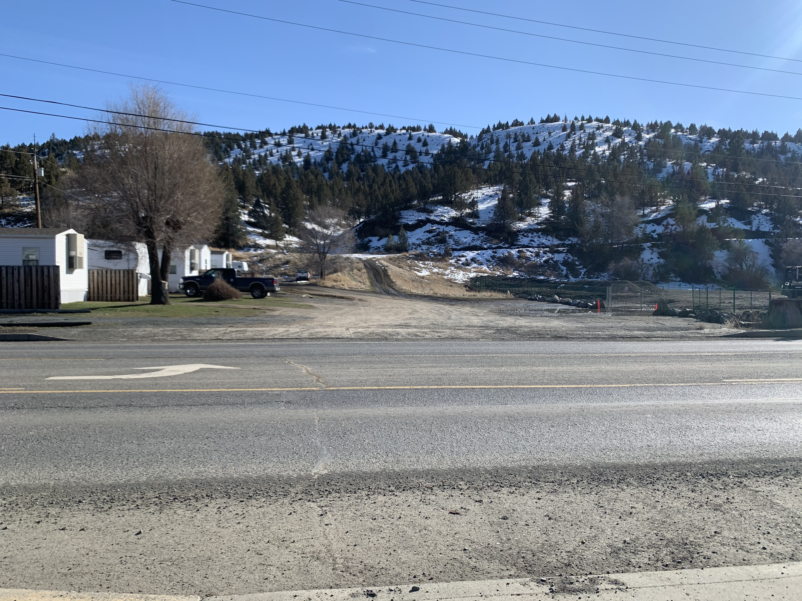

1. ***Location.*** *No such nonconforming use shall be moved in whole or in part to any portion of the lot other than that occupied by such use at the effective date of adoption or amendment of this Code;*

**Finding:** The requested variance *does* propose a change in location of the nonconforming use. Because this standard is not met by the applicant, the nonconforming driveway must be brought into compliance with current code standards, unless a variance is approved.

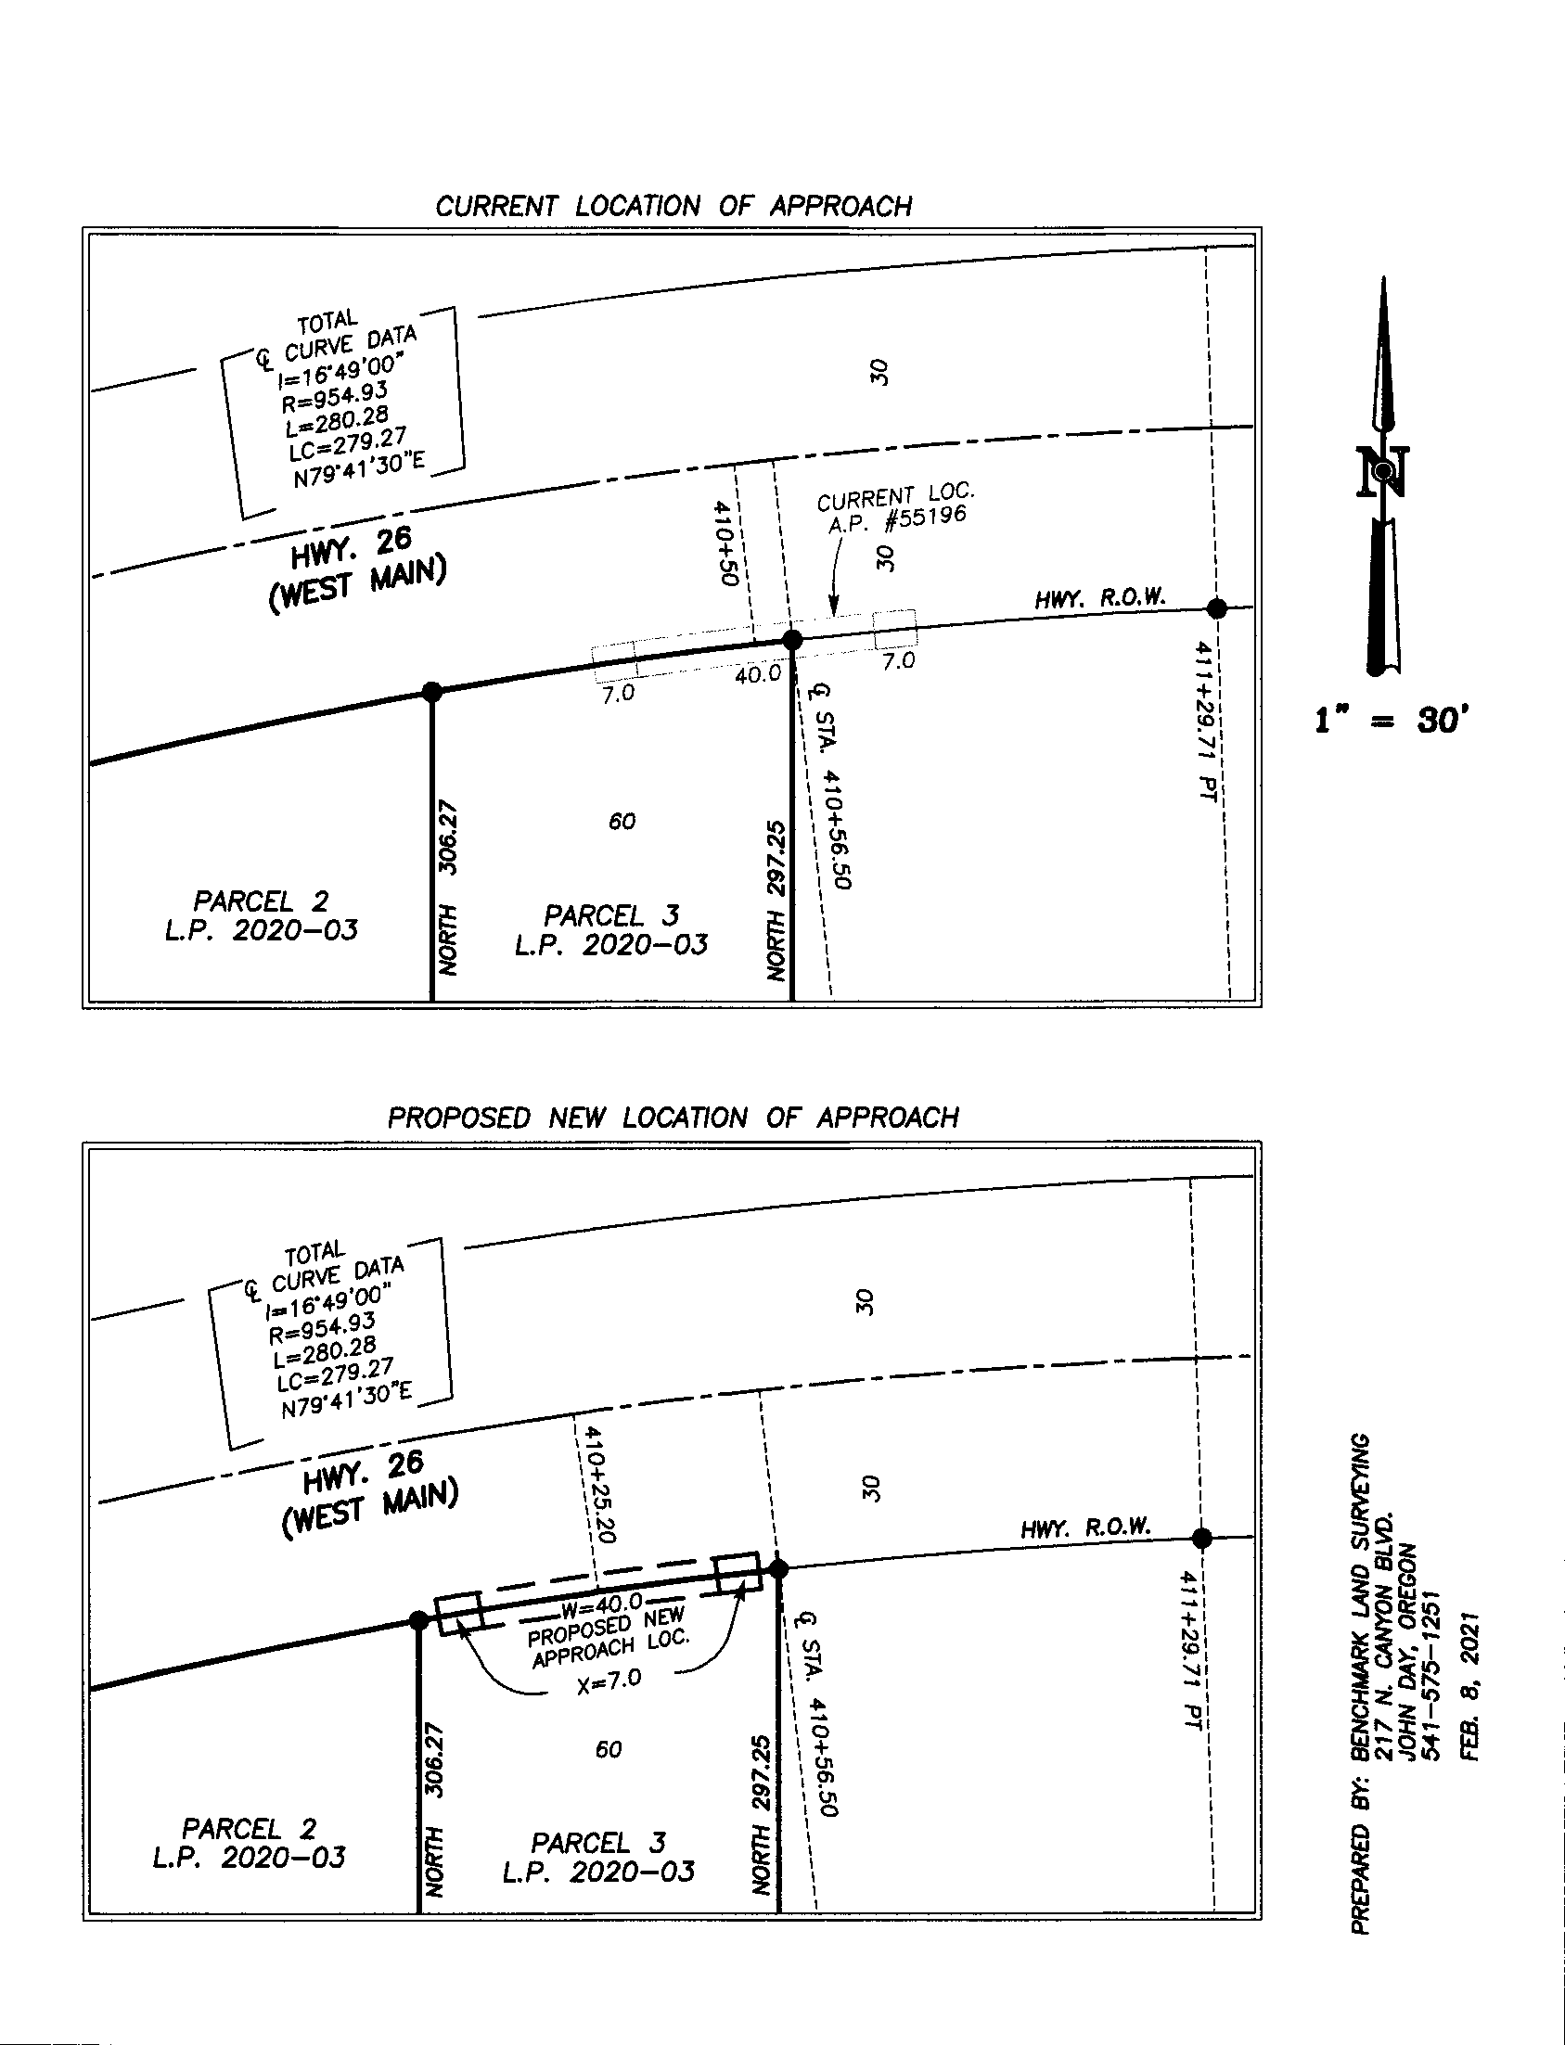

*5-5.2.030 Non-Conforming Development*

*Where a development exists at the effective date of adoption or amendment of this Code that could not be built under the terms of this Code by reason of restrictions on lot area, lot coverage, height, yard, equipment, access, parking, landscaping, its location on the lot or other requirements concerning the development; and the development was lawful when constructed, the development may remain on the site so long as it remains otherwise lawful, subject to the following provisions:*

1. ***Alterations.*** *No such nonconforming development may be enlarged or altered in a way that increases its nonconformity, but any development or portion thereof may be enlarged or altered in a way that satisfies the current requirements of this Code or will decrease its nonconformity;*
2. ***Destruction.*** *Except as expressly allowed by Section 5-2.3.020 (Single Family Dwelling in Downtown District), should such nonconforming development or nonconforming portion of development be destroyed by any means to an extent more than fifty (50) percent of its current value as assessed by the Grant County Assessor, it shall be reconstructed only in conformity with this Code. A residential use lawfully existing in the Downtown and General Commercial zones as of November 24, 2005 may be rebuilt within the same building envelope (setbacks and height) in the event of involuntary damage or destruction due to fire or other event beyond owner’s control, provided the new structure is completed within three (3) years of the property being vacated and it complies with current building and development code requirements;*

**Finding:** The proposal does not increase the nonconformity of the development, nor does it satisfy the current requirements of the code. Because the alteration corrects an encroachment on the neighboring property, the proposal may be considered to decrease the nonconformity of the development. The request does not involve reconstruction after involuntary destruction, so standard B does not apply.

1. ***Roadway Access.*** *The owner of a non-conforming access connection (i.e., street or highway access) may be required to bring the non-conforming access into conformance with this Code and other applicable standards as a condition of the City or other roadway authority approving a new access connection permit, or a change in land use.*

**Finding:** This provision allows the City to require non-conforming access connections to be brought into compliance with Code standards prior to approving a new access connection permit. The roadway authority has preliminarily approved the connection subject to compliance with city Code requirements and/or variance approval by the Planning Commission.

1. ***Relocation or Removal.*** *Should such development be moved for any reason and by any distance, it shall thereafter conform to the regulations of this Code.*

**Finding:** The request proposes the relocation of the nonconforming development and therefore must be brought into compliance with regulations of the Code unless a variance is granted.

*5-5.1.040 Class B Variances*

1. ***Applicability.*** *Class B variances are allowed for requests that do not otherwise meet the criteria under subsection 5-5.1.030 (Class A Variance), pursuant to the limitations under subsections 1-3, below, and the approval criteria in Sections 5-5.1.040C through 5-5.1.040G. Class B variances shall be reviewed using a Type III procedure under Chapter 5-4.1.040.* 
   1. *The Class B variance standards apply to individual platted and recorded lots; properties determined to be Legal Lots of Record under Chapter 5-5.3 are also eligible for Class B variances.*
   2. *The Class B variance procedure shall not be used to modify a standard for lots yet to be created through a partition or subdivision process. Such requests may be approved under the Master Planned Development procedure of Chapter 5-4.5.*

**Finding:** Class A Variances involve limited discretion and may be reviewed administratively. The Class A criteria is not met because the proposal requires more discretion and must be reviewed by the planning commission with consideration of any public testimony. The applicant is eligible for a Class B variance- the development is on an individual platted and recorded lot and the request does not modify a standard for lots yet to be created.

1. ***Approval Criteria.*** *A Class B Variance may be approved only upon finding it meets all of the following criteria:*
   1. *The variance is necessary because the subject Code provision does not account for special or unique physical circumstances of the subject site, existing development patterns, or adjacent land uses.*

**Finding:** There are no special or unique physical circumstances of the subject site, but the necessity for the variance arises from the movement of heavy equipment in and out of the property during and prior to development.

* 1. *The variance is the minimum necessary to address the special or unique physical circumstances referenced in subsection 5-5.1.040B(1).*

**Finding:** The current size of the access is sufficient to address the movement of heavy equipment. The applicant intends to provided evidence at the hearing that a narrower access could not accommodate the use due to the size of the equiptment that will be moving in and out of the property.

* 1. *The variance conforms to the provisions of subsections 5-5.1.040C through 5-5.1.040G, as applicable*

**Finding:** See findings of C-G, below.

* 1. *The variance does not conflict with other applicable City policies or other applicable regulations.*

**Findings:** The proposed variance does not conflict with other applicable City policies or other applicable regulations.

* 1. *The variance will result in no foreseeable harm to adjacent property owners or the public.*

**Findings:** No concerns were submitted to the city regarding the variance request. The owner of the property that the current driveway is encroaching on supports the movement of the access to correct the encroachment, and other adjacent property owners have not expressed concern that the variance would cause them harm. The public will likely benefit from the movement of the wide access point further from the adjacent residential use as a harm reduction measure.

1. ***Variance to Vehicular Access and Circulation Standards (Chapter 5-3.1)*** *Where vehicular access and circulation cannot reasonably be design to conform to Code standards within a particular parcel, shared access with an adjoining property shall be considered. If shared access in conjunction with another parcel is not feasible, the City may grant a variance to the access requirements after finding all of the following:*
   1. *There is not adequate physical space for shared access, or the owners of abutting properties do not agree to execute a joint access easement.*

**Finding:** The possibility of a shared access was not considered by the applicant.

* 1. *There are no alternative access points on the street in question or from another street.*

**Finding:** No alternative access point to the highway was found by the applicant.

* 1. *The access separation requirements cannot be met.*

**Finding:** Access separation requirements are measured from the center of one driveway to the center of the next. The proposed variance will not violate access separation requirements.

* 1. *The request is the minimum variance required to provide adequate access.*

**Finding:** The current approach is sufficient to provide adequate access for the approved use. An increase from the current 40’ size would not be necessary.

* 1. *The approved access or access approved with conditions will result in a safe access.*

**Finding:** The movement of the approach will not decrease its safety. Allowing more space between the movement of heavy equipment and the adjacent residential use will likely increase the safe access for both properties.

* 1. *The vision clearance requirements of Chapter 5-3.1 will be met.*

**Finding:** No visual obstructions between 3 and 8 ft. in height will be placed in the vision clearance areas as shown below. Modifications to this standard are not requested.

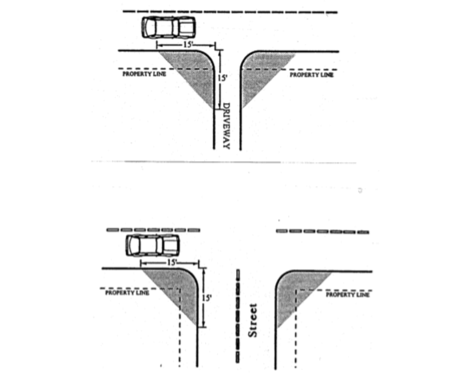

* 1. *Variances for street access deviations shall be subject to review and approval by the roadway authority.*

**Finding:** Oregon Department of Transportation (ODOT) has indicated willingness to approve the movement of the approach despite the unconventionally wide size. ODOT deferred the decision to the City of John Day for final approval.

* 1. *Variances for access deviations on a road right-of-way shall be subject to review and approval by applicable road authority.*

**Finding:** See above findings.

**7. PLANNING COMMISSION MOTION**

After hearing the staff presentation and any public testimony, including any rebuttal, the commission will close the hearing and deliberate. The following motion is suggested:

“I move to recommend City Council approve VAR-21-01 based on the findings contained in the staff report [with conditions, if any].”

*The staff report may be amended during the course of the hearing.*

Attachments:

* Application
* ODOT Access Permit
* Existing and Proposed Access