Hello Heather,

Thank you for your email and interest! I appreciate you reviewing this opportunity with your council.

Below you will find all the details and pricing for the feature article and new brochures we are producing for Grant County Regional Airport. Please let me know ASAP (by December 15th) if you would like to participate.

We have plenty of time to finalize artwork and materials and payment isn’t due until after publishing.

If you have any questions just let me know.

THE ARTICLE & EDITORIAL

Haley Walker, Airport Manager of the Grant County Regional Airport has invited you to take part in an editorial feature that they were chosen for in the upcoming issue of Business View Magazine, in addition to our upcoming quarterly publication Aviation View. The article is part of our series covering Best Practices and Innovations in Airports and Airport Management, with a Focus on Economic Development and the Impact of Regional Airports in the wake of the pandemic.

The 8-10 page article will be based on an interview between Airport Manager, Haley Walker and our Editor-In-Chief. Haley will be discussing the history of the airport, some of the projects and investments that are underway or planned in regard to capital improvements (Corporate Apron Construction, Runway Decoupling and Widening etc), in addition to operations and capabilities, FBO services and amenities, overall airport maintenance, sustainability initiatives, proximity to the John Day Industrial Park and Central Business District, not to mention the significance of the airport as an economic hub in the region, particularly in the wake of Covid-19.

Our expanded coverage also includes keynote forewords for the segment from T.J. Schulz, President of the Airport Consultants Council (ACC); Kurt Edwards, Director General of The International Business Aviation Council (IBAC); and Jeff Finkle, CEO of The International Economic Development Council.

As part of the discussion, Haley wanted to highlight the importance of the strategic partners that have been integral to the recent, ongoing, and future development of the airport, and surrounding region.

OUR MULTI-PLATFORM COVERAGE

Business View Magazine February issue:

The Grant County Regional Airport article is going to be the lead feature in this series for the February edition of Business View Magazine. Business View is a business publication that distributes to more than 877,000 across North America. Our readership is made up of mostly C-Level & VP-Level executives, finance & procurement managers within a few key industry groups including but not limited to: Public Sector Infrastructure, Construction, Manufacturing, Tourism, Technology, Franchising, Oil & Gas, Supply Chain & Logistics, Food & Beverage, Healthcare, Energy, and Green Business. Our informative website receives over 250k unique visitors per month. In 2020, Business View was highlighted by Inc.com as one of the Top 5000 Fastest-Growing Companies in America, and Google now ranks Business View as the leading & largest mass media business publication across all of The Caribbean & Latin America. Visit our website @ www.businessviewmagazine.com

Aviation View Magazine:

The Grant County Regional Airport article will also appear in our quarterly publication, Aviation View Magazine. Aviation view is a general, commercial and industrial aviation-specific publication that is distributed to over 19,000 industry executives specific to the aviation sector. The readership is comprised of professionals in Airport Management, FBOs, Fuel Providers, Engineers/Contractors working in Aviation and Aeronautics, Airlines, Air-Med, Air-Fire and Charters. Visit our website @ www.aviationviewmagazine.com

The Print/Digital Brochures:

Once published we will be producing the new Grant County Regional Airport promotional corporate brochure for their further marketing initiatives. There will be a print version which they’re able to use at industry events and for marketing purposes. The digital version of the brochure (see examples below) will be utilized for additional digital marketing including email and websites.

Social Media/Online Integration/Backlinks and SEO:

All sponsors will be tagged into the social media campaign. The link to the article will be extensively optimized for a minimum two years and should be a top organic search result online. Sponsors will be electronically linked to all online content via backlinks and viewers will be able to click directly through to the sponsor website. This is a great way to boost sponsor company search results. All Business View backlinks are considered “high-value” and Google gives them a higher-level boost.

Regional Exposure:

Following the release of the article, our team will issue a press release to all local media. We typically do this in conjunction with Regional Economic Development Departments, Chambers of Commerce, Convention and Visitors Bureaus. The article is typically picked up by multiple third-party local media outlets.

THE INVITATION

Your company is one of a very select group of strategic partners that Grant County Regional Airport Manager, Haley Walker, highlighted as being integral to the development, operations, and growth of the Grant County Regional Airport and surrounding region. They have invited you to share in their exposure by way of a Sponsorship which will include a corporate advertisement, preferred partner mention and optional editorial contribution to appear within the article and new corporate brochure.

SPONSORSHIP OPTIONS & PRICING

All sponsorship packages include the following:

o Inclusion within the pages of the article and all versions of the brochure
o Share in all online promotion of the content which will occur for two years from launch of the article
o Preferred Vendor listing which will appear within the article, brochure, websites and will appear on internet search and social media
o Full use of our creative team to design the ad, subject to your approval
o All ad options include SEO and keyword search links to the article online.
o Payment isn’t due until after release of publication
o Prices quoted are a flat rate (inclusive of tax) in USD and payment terms are available upon request

TITLE sponsor: $9850 USD

o DOUBLE page ad, full color
o Includes a FULL page editorial contribution (400 words)
o Includes a mention on the cover of the magazine
o Includes a mention in the subscriber email along with website and live link
o Company banner to appear on the inside cover of the magazine
o Company banner will appear on the homepage of the website for 30 days
o We will host your own sponsorship on our website – it will have its own unique link and landing site that you can share
o Search Engine Optimization for your company name
o We will turn your sponsorship into a brochure with its own cover which you can approve
o Includes 100 printed copies of the brochure upon completion
o Full approval over editorial/creative content and full use of editorial/creative staff
o First ad to appear in article/brochure
o Only one Title sponsor available

GOLD sponsor: $4950 USD

o FULL page ad, full color
o Includes a HALF page editorial contribution (200 words)
o Full approval over editorial content and full use of editorial staff
o Prime positioning within the article/brochure. First spot following Title sponsor

SILVER sponsor: $2950 USD

o HALF page ad, full color
o Includes 1 paragraph editorial mention
o Full approval over the content of the editorial

BRONZE sponsor: $1650 USD

o QUARTER page, ad full color

CLICK THE COVERS BELOW TO VIEW OUR MEDIA KIT & AD SAMPLES BOOKLET:

CLICK THE COVERS BELOW TO VIEW RECENT ISSUES OF BUSINESS VIEW:

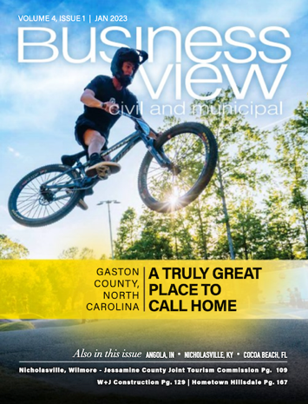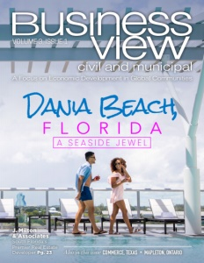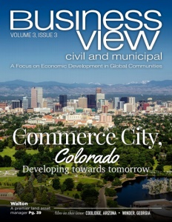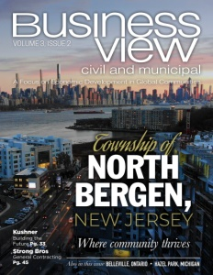
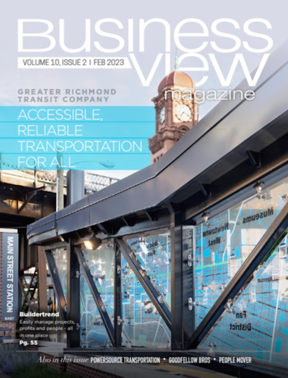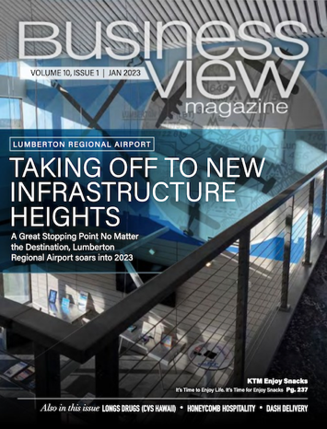

CLICK THE COVERS BELOW TO VIEW RECENT ISSUES OF AVIATION VIEW:

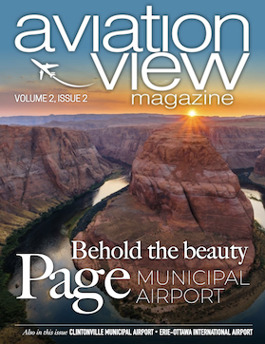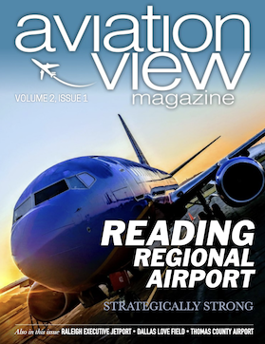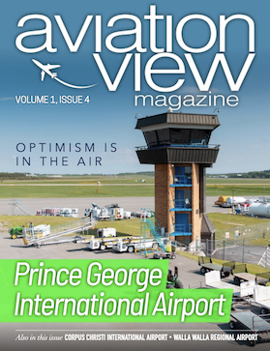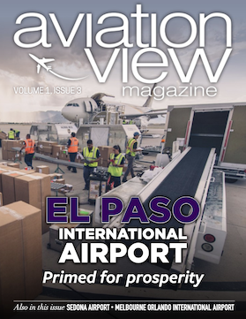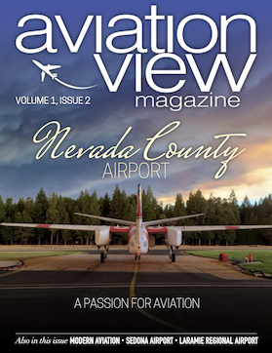

CLICK THE COVERS BELOW TO VIEW A PAST BROCHURE:

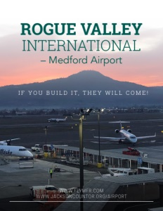

The fine print:

- Any cancellations must be made within 5 business days of booking.
- In the event that Business View is unable to receive final ad copy from client, Business View will develop and use ad placement on behalf of client.

Matthew Mitchell
Chief Operating Officer

O (USA) 1-239-344-7538
O (CAN) 1-250-984-1333
O (AUS) 61-2-7202-1499

Business View Publishing

USA | CANADA | CARIBBEAN | OCEANIA

BUSINESS VIEW REVIEWS
SUBSCRIBE TO BUSINESS VIEW
BOOK A MEETING WITH MATTHEW

