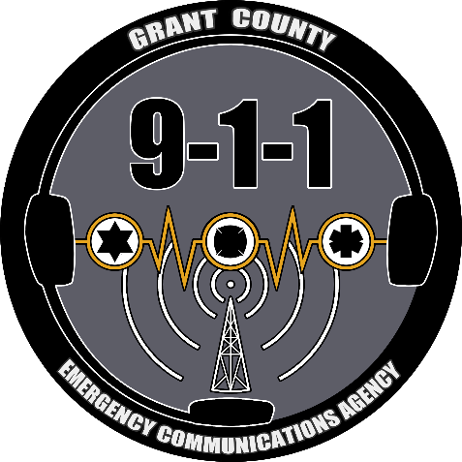
Application for Budget Committee
2023-2026

Contact Information
Name:
Street Address:
Mailing Address:
City/State/Zip Code:
Home Phone:
Work Phone:
E-Mail Address:

Background

Years of Residence in Grant County:
Place of Employment:
Occupation:
Educational Background:
Prior Civic Activities:

Special Skills or Qualifications
Summarize any special training, skills or experience you may have pertinent to the Budget Committee.

Motivation
Discuss your motivation for serving on this committee.

Agreement and Signature
By submitting this application, I affirm that the facts set forth in it are true and complete. I understand that if I am accepted as a volunteer, any false statements, omissions, or other misrepresentations made by me on this application may result in my immediate dismissal.

Name (printed)
Signature
Date

Our Policy
It is the policy of the Grant County Emergency Communications Agency to provide equal opportunities without regard to race, color, religion, national origin, gender, sexual preference, age, or disability.

Thank you for completing this application form and for your interest in volunteering with us.

