# MEMORANDUM

DATE: January 31, 2019

TO: John Day Innovation Gateway Area Plan Team

FROM: Kevin Chewuk, DKS Associates

SUBJECT: **Technical Memo #2:**

Baseline Transportation System Opportunities and Needs Assessment P18194-000

This memorandum summarizes the multimodal transportation system and analysis for the John Day Innovation Gateway Area Plan study area. Included is an inventory of the existing transportation facilities, a safety evaluation of the roadways, and a qualitative review of the pedestrian, bicycle, transit and motor vehicle networks.

# Study Area

The study area encompasses 83-acres on the west side of the City of John Day and is generally bounded by Valley View Drive to the north, Bridge Street to the east, W Main Street (US 26 / US 395) to the south, and Patterson Bridge Road to the west.

Figure 1: Study Area

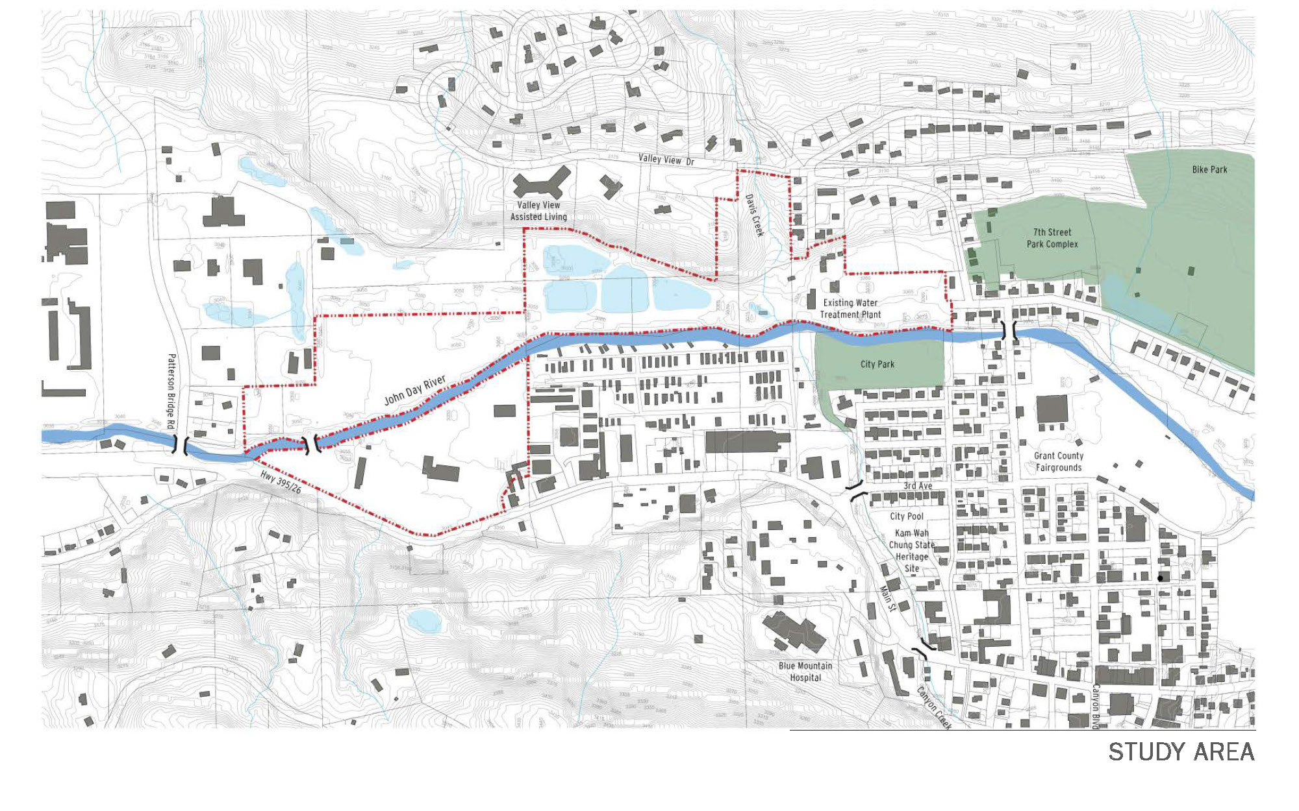

**Study Area**

# Where do People Want to Go?

One of the first steps in planning for an effective transportation system is gaining an understanding of the key destinations that people travel to throughout the City. Demand for travel is created by locations where people go to work, school, or to take care of other daily needs. These destinations are referred to as activity generators (or trip attractors). Activity generators represent important starting and ending points for travel in John Day, and they provide a basis for assessing important travel patterns.

## Within the City

John Day has numerous activity generators that attract residents and visitors alike. The most common categories of activity generators in the City include the following:

* Recreational/Entertainment (e.g., 7th Avenue Sports Complex, Kam Wah Chung State Heritage Site, John Day River)
* Schools (e.g., Blue Mountain Community College, Grant Union High School)
* Places of employment (e.g., Blue Mountain Hospital)
* Shopping (e.g., Downtown John Day, grocery stores, shopping centers, restaurants)
* Community/Government (e.g., City Hall, John Day Senior Center, Gleason Pool)
* Public Transportation (e.g., People Mover bus stop)

Each of these categories of activity generators represents important starting and ending points for travel and provides a good basis for planning ideal routes.

## Outside of the City

Having safe and efficient access to areas outside of the City is critical for many people who either live or work outside of John Day. Much of the traffic in John Day, especially during the weekday peak periods, is related to employment. As shown in Table 1, more than 60 percent of the workers in John Day live in another City that is located more than ten miles away. Residents of John Day also contribute to travel between cities, as shown in Table 2. Nearly half of workers living in John Day commute to employment locations at least ten miles outside of the City.

|  | **Table 1: Where John Day Workers Live** | | | |
| --- | --- | --- | --- | --- |
|  | **John Day workers who:** | **Percent of John Day Residents** | **Distance from John Day** |  |
|  | **Live in John Day** | 23% | - |  |
|  | **Live outside John Day** | 77% | - |  |
|  | *Live in Canyon City* | *9%* | *2+ miles* |  |
|  | *Live in Mount Vernon* | *6%* | *8+ miles* |  |
|  | *Live in Prairie City* | *3%* | *13+ miles* |  |
|  | *Live in Dayville* | *3%* | *30+ miles* |  |
|  | *Live in Seneca* | *2%* | *25+ miles* |  |
|  | *Live in Other Cities* | *54%* | *40+ miles* |  |
|  | Source: Home Destination Report, On The Map, US Census Bureau, 2015. | | | |

|  | **Table 2: Where John Day Residents Work** | | | |
| --- | --- | --- | --- | --- |
|  | **John Day residents who:** | **Percent of John Day Workers** | **Distance from John Day** |  |
|  | **Work in John Day** | 38% | - |  |
|  | **Work outside John Day** | 62% | - |  |
|  | *Work in Canyon City* | *11%* | *2+ miles* |  |
|  | *Work in Mount Vernon* | *2%* | *8+ miles* |  |
|  | *Work in Prairie City* | *2%* | *13+ miles* |  |
|  | *Work in Other Cities* | *47%* | *25+ miles* |  |
|  | Source: Work Destination Report, On The Map, US Census Bureau, 2015. | | | |

# Key Demographics

Demographic characteristics such as age and income play a key role in determining mode of transportation. John Day residents with lower incomes, as well as the youngest and oldest residents, often account for more trips via walking, biking and public transportation.

As seen in Table 3, about 28 percent of John Day residents are school-age children, while 17 percent of residents are over 65. The median income of John Day is around $44,000.

|  | **Table 3: Key Demographics in John Day** | | |
| --- | --- | --- | --- |
|  | **Demographic** | **John Day** |  |
|  | **Age (by percent of residents)** |  |  |
|  | *School-Aged (Under 18)* | *28%* |  |
|  | *College-Aged (18-24)* | *7%* |  |
|  | *Middle-Aged (25 to 64)* | *48%* |  |
|  | *Retired-Aged (65+)* | *17%* |  |
|  | **Median Household Income** | $44,432 |  |
|  | Source: US Census Bureau, 2013-2017 American Community Survey. | | |

# Existing Transportation Infrastructure

Much of the land within the study area is rural, with the exception of land surrounding W Main Street through downtown John Day. As a result, many roadways are not constructed to urban standards. Evaluating the transportation impacts of rezoning the land requires an understanding of the current transportation facilities in this area. This section includes descriptions of existing infrastructure to serve pedestrian, bicycle, transit and motor vehicle modes of travel in the immediate John Day Innovation Gateway Area Plan study area.

## Roadway System

The major characteristics of the roadways in the study area are summarized in Table 4 and can be seen in Figure 2. The only streets providing for higher capacity motor vehicle movement through the study area is W Main Street and S Canyon Boulevard, which are classified by the state as a Statewide Highways. W Main Street runs east-to-west, and maintains a two-lane (i.e., one through lane in each direction) to three-lane cross-section (i.e., one through lane in each direction and a center turn lane) through the study area. Posted speeds along the highway in the study area range between 25 and 35 miles per hour. It is designated as a scenic byway and freight route, and some segments are within a special transportation area or urban business area.

S Canyon Boulevard runs north-to-south, intersecting with W Main Street. It maintains a two-lane cross-section with posted speeds between 25 and 35 miles per hour. It is designated as a freight route, and some segments are within a special transportation area or urban business area.

Bridge Street and Dayton Street run north-to-south, while 3rd Avenue runs east-to-west through the center of John Day, connecting to W Main Street. These streets are classified as collectors and generally have lower vehicle-carrying capacity than the highway. Other key collector streets in the City include Patterson Bridge Road and Screech Alley. All other roadways in the study area are local streets and primarily serve local traffic traveling to and from the highway.

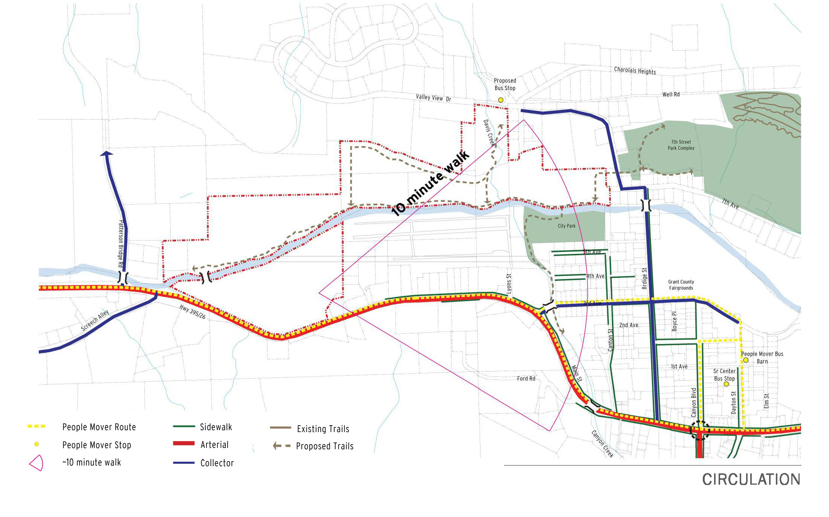

Figure 2: Existing Transportation Facilities

|  | **Table 4: Study Area Roadway Characteristics** | | | | |
| --- | --- | --- | --- | --- | --- |
|  | **Roadway (limits)** | **Functional Classification\*** | **Cross section** | **Special Designations** |  |
|  | W Main Street - US 26 / US 395  (Patterson Bridge Road to 3rd Avenue) | Statewide | 2 to 3 lanes | Scenic Byway; Freight Route; Urban Business Area (City limits to 3rd Avenue) |  |
|  | W Main Street - US 26 / US 395  (3rd Avenue to US 395) | Statewide | 2 lanes with on-street parking | Scenic Byway; Freight Route; Urban Business Area (3rd Avenue to Canyon Creek); Special Transportation Area (Canyon Creek to US 395) |  |
|  | S Canyon Boulevard - US 395  (Canyon Boulevard to south UGB) | Statewide | 2 lanes with on-street parking | Freight Route; Special Transportation Area (US 26 / US 395 to SW 3rd Avenue); Urban Business Area (SW 3rd Avenue to south UGB) |  |
|  | Patterson Bridge Road  (US 26 / US 395 to northern terminus) | Collector | 2 lanes | None |  |
|  | Screech Alley  (US 26 / US 395 to Bench Road) | Collector | 2 lanes | None |  |
|  | 7thAvenue  (Bridge Street to western terminus) | Local Street | 2 lanes | None |  |
|  | 3rdAvenue  (US 26 / US 395 to Bridge Street) | Collector | 2 lanes | None |  |
|  | Bridge Street  (US 26 / US 395 to 7th Avenue) | Collector | 2 lanes | None |  |
|  | Dayton Street  (US 26 / US 395 to 3rd Avenue) | Collector | 2 lanes | None |  |
|  | *Source: Oregon Highway Plan; John Day Transportation System Plan, December 1996. | | | | |

## Pedestrian and Bicycle System

Table 5 and Figure 2 shows the key roadways with pedestrian and bicycle facilities. Due to the rural nature of the abutting land uses, many streets have not been improved to urban standards and generally lack accommodation for pedestrian and bicycle users. The exception being segments of W Main Street, S Canyon Boulevard, 3rdAvenue, Bridge Street, Dayton Street and a few local streets (i.e., Canyon Boulevard, Canton Street, 2nd Avenue, 4th Avenue and 5th Avenue), which provides a sidewalk on at least one side of the street for pedestrians. Bike lanes are also provided for bicycle travel along S Canyon Boulevard between SW 2nd Avenue and SW 6th Avenue.

W Main Street and S Canyon Boulevard are important connections for pedestrian and bicycle travel in the City. They provide the only current route for pedestrians and bicyclists to the western, eastern and southern parts of the City. Those walking or biking along portions of these highways often have to walk along the edge or share the travel lane with motor vehicles. Motor vehicle traffic volumes along these highways are over 5,000 vehicles per day and the posted speeds range up to 35 miles per hour. These conditions are generally not conducive to comfortable shared walking and biking travel conditions. Main Street through John Day is also designated as part of the Old West Oregon Scenic Bikeway. Much of this route lacks accommodations for bicyclists.

|  | **Table 5: Study Area Pedestrian and Bicycle Characteristics** | | | |
| --- | --- | --- | --- | --- |
|  | **Roadway (limits)** | **Pedestrian Facilities** | **Bike Facilities** |  |
|  | W Main Street - US 26 / US 395  (Patterson Bridge Road to 3rd Avenue) | Sidewalk on north side from 3rd Avenue to the west for 0.25 miles; Intermittent sidewalks on south side | None |  |
|  | W Main Street - US 26 / US 395  (3rd Avenue to US 395) | Sidewalk on both sides from Ford Road to US 395; Sidewalk on north side only west of Ford Road | None |  |
|  | S Canyon Boulevard - US 395  (Canyon Boulevard to south UGB) | Sidewalk on both sides north of SW 3rd Avenue; Sidewalk on west side only south of SW 3rd Avenue | Bike lanes south of SW 2nd Avenue; None north of SW 2nd Avenue |  |
|  | Patterson Bridge Road  (US 26 / US 395 to northern terminus) | None | None |  |
|  | Screech Alley  (US 26 / US 395 to Bench Road) | None | None |  |
|  | 7thAvenue  (Bridge Street to western terminus) | None | None |  |
|  | 3rdAvenue  (US 26 / US 395 to Dayton Street) | Sidewalk on both sides from US 26 / US 395 to Brent Drive; none east of Brent Drive | None |  |
|  | Bridge Street  (US 26 / US 395 to 7th Avenue) | Sidewalk on both sides from US 26 / US 395 to 3rd Avenue; Sidewalk on east side only north of 3rd Avenue | None |  |
|  | Dayton Street  (US 26 / US 395 to 3rd Avenue) | Sidewalk on west side south of 1st Avenue; None north of 1st Avenue | None |  |
|  |  | | | |

### Highway Crossings

As a major street connection through the area, W Main Street should not be a barrier to pedestrian and bicycle travel between the neighborhoods and businesses on the north and south side of the street. While most of the south side of the highway is undeveloped, especially areas towards the west side of the City, safe and comfortable pedestrian and bicycle crossings should be provided in convenient areas to encourage ease of access.

W Main Street is currently a two to three lane arterial street with a posted speed up to 35 miles per hour. The S Canyon Boulevard - US 395 intersection provides a signalized opportunity for pedestrians and bicyclists to cross W Main Street. Marked crosswalks are also available near the Riverside Mobile Home Park, Old West Federal Credit Union and at Dayton Street. The Riverside Mobile Home Park crossing includes signage. Curb ramps and street lighting are provided at the crossings, although the lighting is not pedestrian scaled.

### River Crossings

There are two bridges along public streets and one private bridge that cross the John Day River. The bridges are located at Patterson Bridge Road and Bridge Street, while the private crossing is located about 850 feet to the east of Patterson Bridge Road. These crossings are the only existing connections between the north and south side of the City. The bridge at Patterson Bridge Road does not provide facilities for pedestrian or bicycle travel, while the one at Bridge Street provides a sidewalk on one side.

There are also two bridges over Canyon Creek, providing the only existing improved connection between the east and west part of the City. The bridges are located at NW 3rd Avenue and W Main Street. These bridges provide sidewalks on both sides for pedestrian travel, but lack bicycle facilities.

## Transit

Transit service is provided in John Day and other nearby cities by the Grant County People Mover via several fixed bus routes and a Dial-a-Ride service. The People Mover connects riders in John Day to nearby cities including Bend, Redmond, Prineville, Mount Vernon, Monument, Pendleton, Walla Walla, Burns, Prairie City and Baker City. The Bend, Redmond, Prineville, Mount Vernon route runs Monday, Wednesday and Friday; the Monument route runs on Thursdays; the Pendleton and Walla Walla route runs on Tuesdays; the Burns route runs on the 1st, 3rd, and 5th Thursday of the month; and the Prairie City and Baker City route runs on the 2nd and 4th Thursday of the month. Each of these routes typically depart John Day in the morning and return in the evening.

Most routes pick-up and drop-off passengers at the People Mover Bus Depot located on NE Dayton Street near at NE 1st Avenue. However, the Monument to John Day route pick-ups and drop-offs passengers at the Senior Center parking lot on NE Dayton Street south of NE 1st Avenue. Transit users in the John Day Innovation Gateway Area Plan study area are generally more than one mile from the closest bus stop on NE Dayton Street (greater than the typical trip length for the average walking trip).

# Transportation System Performance

The transportation infrastructure in the study area was evaluated with a variety of measures in order to document the existing deficiencies of the transportation system. Information reviewed included safety of the roadways and a qualitative review of the pedestrian, bicycle networks, transit and motor vehicle networks.

## Safety Evaluation

Safety of the roadways in the study area was assessed through historic collision data to identify deficiencies. The data along the roadways was reviewed to identify potential patterns for motor vehicle, pedestrian, and bicyclist collisions.

Collision data from the past five years (January 2013 through December 2017) was obtained from the Oregon Department of Transportation (ODOT) for all roadways within the John Day Innovation Gateway Area Plan study area. Over the past five years, 41 collisions, or an average of about ten per year, were identified along study area roadways. A majority of these collisions (26 of the 41) involved drivers running into fixed objects or failing to yield when making a turn. None of the collisions involved a pedestrian or bicyclist.

The severity of the collisions was generally low, with most (31 of the 41 collisions) involving property damage only (no injuries). There were three collisions involving major injuries, two involving moderate injuries and five involving minor injuries. There were no fatalities over the past five years. All of the collisions involving serious injuries occurred along Main Street, one each at S Canyon Boulevard and Gunther Street, when a driver rear-ended another driver, and another at Hillcrest Road, when a driver collided with an animal.

### Roadway Segment Safety

A segment collision rate along W Main Street was calculated to provide a picture of roadway safety. Segment collision rates are determined by dividing the number of collisions along the segment by the total vehicle traffic along the segment and are reported in crashes per million vehicle miles traveled (MVMT). Since W Main Street through the study area includes no major intersections, it was analyzed as a single segment and crash rates were compared to the five-year average of state highway crash rates published in Table II of the 2016 ODOT Crash Rate Book.

The collision rate calculated (based on the past five years of collision data) for the highway segment can be seen in Table 6. The segment collision rate was normal when compared to other similar highway segments across Oregon.

|  | **Table 6: Highway Segment Collision Analysis** | | | | | | | | | |
| --- | --- | --- | --- | --- | --- | --- | --- | --- | --- | --- |
|  | **Roadway (limits)** | | **Distance (miles)** | | **Total Collisions (2013 to 2017)** | | **Observed Crash Rate (per MVMT)** | **Statewide Collison Rate (per MVMT)** | **Over Statewide Collison Rate** |  |
|  | W Main Street - US 26 / US 395  (Patterson Bridge Road to S Canyon Boulevard-US 395) | | 1.23 | | 16 | | 1.17 | 1.37 | No |  |
|  |  |  | |  | |  | | | | |

## Transportation Network Conditions

To assess the pedestrian, bicycle, transit and motor vehicle network conditions within the study area, a high-level qualitative evaluation was conducted based on the ODOT Qualitative Multimodal Assessment methodology[1]. The quality and availability of various characteristics are rated system-wide as “Excellent”, “Good”, “Fair”, or “Poor”. The intent of the analysis is to show the extent to which each network provides a level of comfort and safety for users. The analysis will be used to inform, create, and confirm recommendations for improvement projects.

### Pedestrian Network Conditions

For the pedestrian network evaluation, consideration is given to the presence of a sidewalk or path, a buffer zone (i.e., bike lane, shoulder, landscape strip, or on-street parking) and street lighting, and the number of travel lanes and travel speeds along the adjacent roadway. In the study area, an “Excellent” rating requires sidewalks on both sides of the roadway, along with a buffer. A “Good” rating requires a sidewalk on at least one side of the roadway, along with a buffer. A “Fair” rating is given to a roadway with a sidewalk on at least one side, but without a buffer. A “Poor” rating denotes gaps within the sidewalks along that corridor.

Figure 3 summarizes the pedestrian network conditions in the study area. Overall, the network rates poorly in the study area. This result is not surprising given the rural nature of much of the area. The segment of Main Street between NW 3rd Avenue and NE 3rd Avenue rated as “Good” or “Excellent” since it has a sidewalk on at least one side of the roadway, along with on-street parking in some areas, while the segment west of NW 3rd Avenue rated as “Fair” since it has a curb-tight sidewalk. Bridge Street south of NW 3rd Avenue and S. Canyon Boulevard north of SW 3rd Avenue rated as “Excellent” since they have sidewalks on both sides, along with on-street parking.

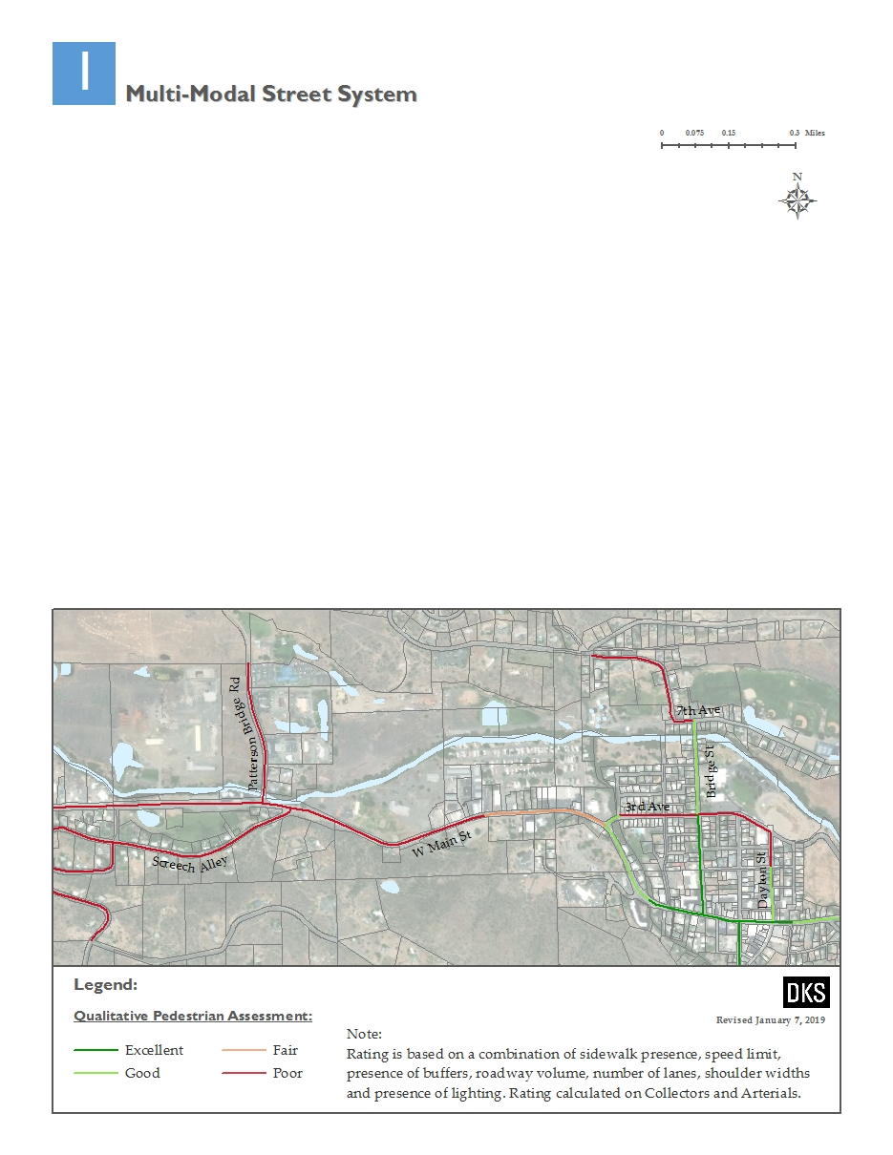

Figure 3: Qualitative Pedestrian Assessment

### Bicycle Network Conditions

For the bicycle network evaluation, consideration is given to the presence and width of bike facilities (i.e., bike lane, shoulder, path, shared lane markings), grade and pavement conditions of the roadway, and the number of travel lanes, motor vehicle volumes, and travel speeds along the adjacent roadway. For the bicycle network evaluation of the study area, an “Excellent” rating requires separated bicycle facilities. A “Good” rating requires adequate bicycle facilities and width given the segment characteristics. A “Fair” rating is given to a roadway with bicycle facilities, but without the preferred facility type or width. A “Poor” rating denotes gaps within the bike network along that corridor.

Figure 4 summarizes the bicycle network conditions in the study area. Bridge Street, Dayton Street and 3rd Avenue rated as “Good” since they are level roadways with low traffic volumes, and slow motor vehicle travel speeds. Several streets rated as “Fair” since they have slightly higher motor vehicle travel speeds or volumes. Several segments of Main Street rated as “Poor” due to it having no bike facilities with higher motor vehicle volumes.

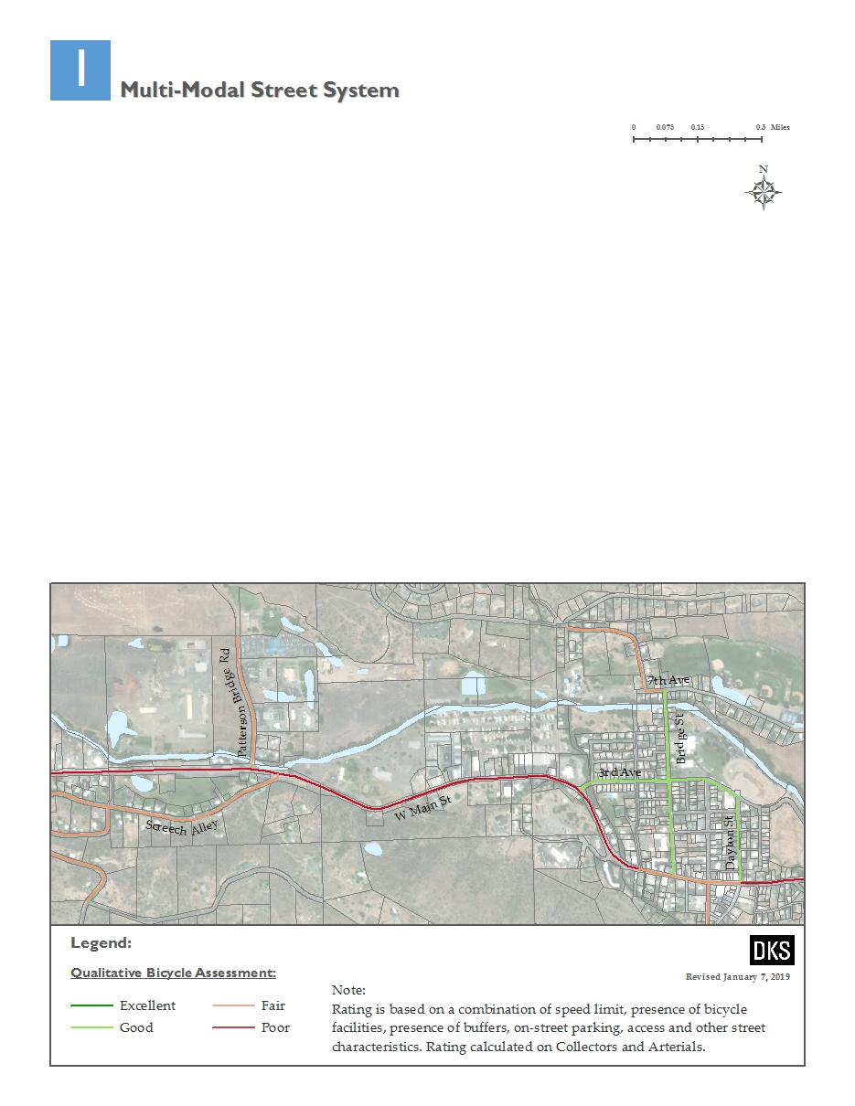

Figure 4: Qualitative Bicycle Assessment

### Transit Network Conditions

For the transit network evaluation, consideration is given to the service frequency and on-time reliability, service speed and travel times, transit stop amenities and connections to the pedestrian and bike network. In the study area, an “Excellent” rating requires a transit stop within a quarter-mile that is well connected to the pedestrian and bike network, with amenities and frequent service. A “Good” rating requires a transit stop within a quarter-mile that is well connected to the pedestrian and bike network, but without amenities or frequent service. A “Fair” rating is given to a roadway with a transit stop within a quarter-mile but is not connected to the pedestrian and bicycle network and lacks amenities or frequent service. A “Poor” rating denotes no transit service along that corridor.

Figure 5 also summarizes the transit network conditions in the study area. Overall, the network rates poorly in the study area. The roadway segments in central John Day rated “Fair” since they are within ½ mile of the transit stop. All other segments rated “Poor” since they are not within a comfortable walking distance of the transit stop.

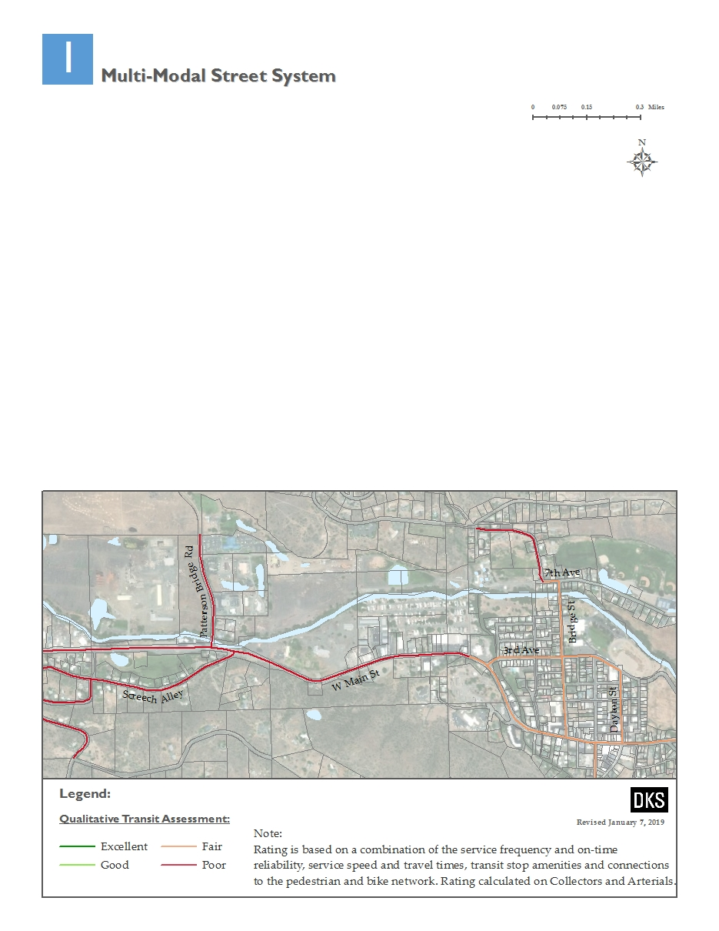

Figure 5: Qualitative Transit Assessment

### Motor Vehicle Conditions

For the motor vehicle network evaluation, consideration is given to the level of traffic and queuing on the mainline, and side-street intersection approaches and safety of the corridor including presence of street lighting, driveway density, intersection spacing, posted speeds, number of fixed objects, presence of a median or traffic separator and turn lanes. For the motor vehicle network evaluation of the study area, an “Excellent” rating requires no congestion and safe roadway conditions. A “Good” rating requires minimal congestion and reasonably safe roadway conditions. A “Fair” rating is given to a roadway with minimal congestion, but with less than desirable roadway conditions. A “Poor” rating denotes congestion or unsafe conditions along that corridor.

Figure 6 also summarizes the motor vehicle network conditions in the study area. Overall, the network rates highly in the study area. Most segments rated “Excellent” or “Good” since they have low levels of traffic and safe roadway conditions. A few segments of W Main Street rated “Fair” since they have a greater density of driveways.

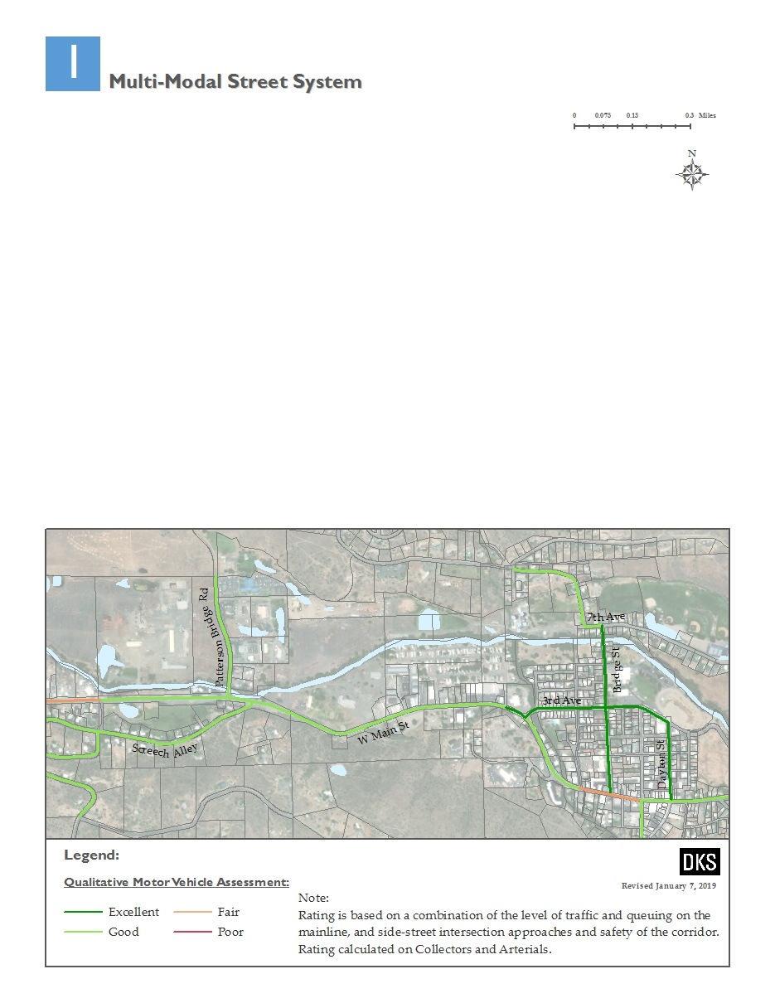

Figure 6: Qualitative Motor Vehicle Assessment

### Motor Vehicle Volumes

Average annual daily traffic (AADT) volumes along W Main Street were obtained from ODOT[2]. The data indicates AADT volumes range from around 4,800 near Patterson Bridge Road, 5,900 near NW 3rd Avenue, to 6,200 near S Canyon Boulevard-US 395.

### Trucks

Within John Day, W Main Street - US 26 / US 395 and S Canyon Boulevard - US 395 are classified as Oregon Freight Routes. Most of the local freight generators are located at the west and south end of the City. Heavy vehicles account for approximately four percent of the traffic on W Main Street west of NW 3rd Avenue and seven percent of the traffic on W Main Street east of NW 3rd Avenue through John Day.

# Opportunities and Needs

Below is a summary of key opportunities and needs identified in the 1996 John Day Transportation System Plan (TSP), 2009 John Day Local Street Network Plan, or resulting from the analysis of baseline transportation conditions.

## Pedestrian and Bicycle Network

The pedestrian and bicycle network in the study area is undeveloped and disconnected from the rest of the City. Identified opportunities and needs include:

* Sidewalks on W Main Street. This route is needed to link Patterson Bridge Road with the sidewalk that terminates west of NW Lyons Street. Topography constraints will hinder the ability to construct a sidewalk on the south side of W Main Street through the study area, but a continuous sidewalk on the north side is feasible. The ODOT standard for sidewalk width is six feet, with a minimum width of five feet acceptable on local streets. The unobstructed travel way for pedestrians should be clear of utility poles, sign posts, fire hydrants, vegetation and other street furnishings.
* Bikeway on W Main Street. This route is needed to link to surrounding areas of the City. Currently the narrow shoulders are generally not suitable for bike travel. ODOT standard width for a bicycle lane is six feet. The minimum width of a bicycle lane against a curb or adjacent to a parking lane is five feet. A bicycle lane may be as narrow as four feet, but only in very constrained situations. Bike lanes are most appropriate on arterials and collectors, where high traffic volumes and speeds warrant greater separation of travel modes.

Paved roadway shoulders not specifically designated for bicycle travel often accommodate bicyclists traveling along rural routes in Oregon. ODOT recommends a six-foot paved shoulder to adequately provide for bicyclists, and a four-foot minimum width in constrained areas.

* Shared-use Path Network. A shared-use path along the north side of the John Day River linking Patterson Bridge Road with Bridge Street is envisioned to provide a more comfortable alternative route to W Main Street (see Figure 7). A pedestrian/bicycle crossing of the John Day River and a path along the east side of Canyon Creek is also planned to connect the John Day River Trail with the Kam Wah Chung site. An additional trail network is envisioned to the north, linking Valley View Drive with the John Day River Trail.

Shared-use paths are typically separated from the street and used by a variety of non-motorized users, including pedestrians, bicyclists, skateboarders, and runners. Shared-use paths are typically paved (asphalt or concrete), but unpaved smooth surfaces may also meet Americans with Disabilities Act (ADA) standards. Shared-use paths are usually wider than an average sidewalk (i.e. 10 – 14 feet). The width may be reduced to as little as eight feet where bicycle and pedestrian volumes are expected to be low, good passing opportunities can be provided, and maintenance vehicle loads are not expected to damage the pavement.

Image Source: Sisul Engineering

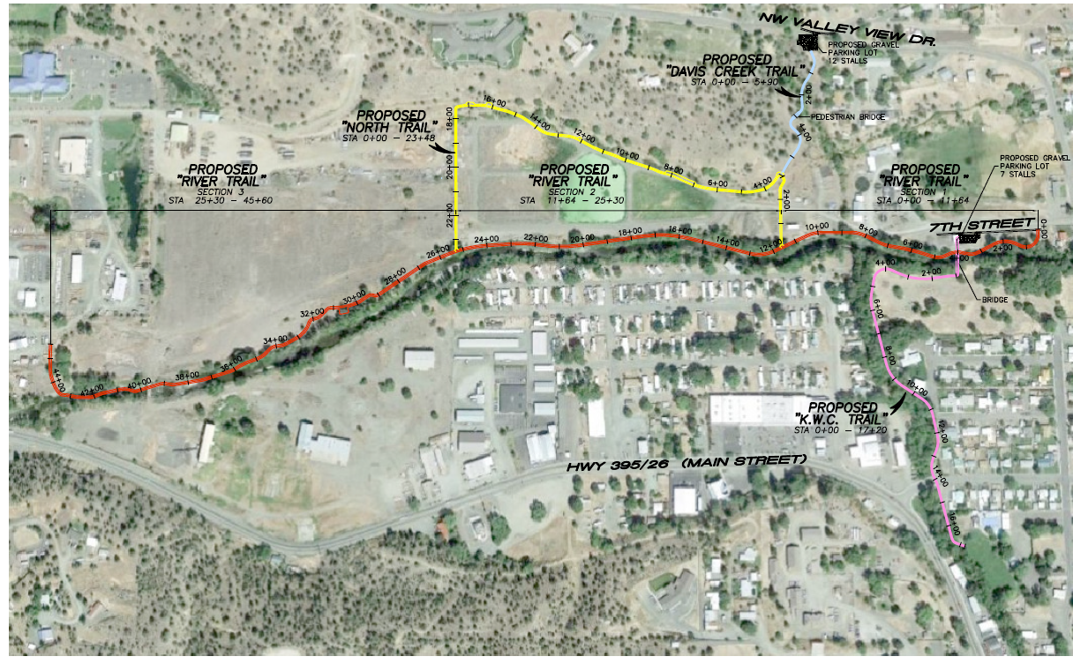

Figure 7: Planned Shared-Use Paths

* Pedestrian facilities on Patterson Bridge Road. Patterson Bridge Road has low enough traffic volumes (expected daily volume less than 1,000 vehicles) and travel speeds (expected 85th percentile speed 28 mph or less), and enough pavement width that it could be suitable to designate a section of the existing street for walking. Striping a portion of the street could provide a dedicated area for walking without physically separating the facility from the roadway. Striped shoulders visually narrow the roadway and may slow traffic, making it more pedestrian friendly. The designated walking area can be painted to increase visibility.

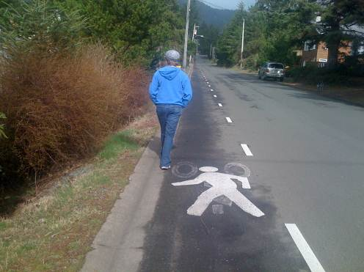

Striped Area of Roadway for Pedestrian Use

Advantages:

1. Cost-effective and easy to implement
2. No additional pavement or street widening needed
3. Provides stable surface for pedestrian travel
4. Striping will help alert drivers to expect pedestrians along the route
5. Ease of maintenance with ordinary street cleaning equipment

Disadvantages:

1. Would require improved street lighting in some areas, increasing utility costs
2. Less comfortable than separated sidewalks or shared-use paths
3. Increased maintenance with additional striping and/or painted street surface
4. No on-street parking on the side with the striped walking area.

* Bicycle facilities on Patterson Bridge Road. Designate Patterson Bridge Road as a shared roadway to connect W Main Street with a potential shared-use path adjacent to the John Day River. Shared roadways are facilities where bicyclists and motorists share the same travel lane. The most suitable roadways for shared bicycle use are those with low speeds (25 mph or less) and low traffic volumes (3,000 vehicles per day or fewer). Signed shared roadways are shared roadways that are designated and signed as bicycle routes and serve to provide continuity to other bicycle facilities (e.g. bicycle lanes) or to designate a preferred route through the community.

Common practice is to sign the route with standard Manual on Uniform Traffic Control Devices (MUTCD) green bicycle route signs with directional arrows. However, these facilities can be improved with the addition of yellow bicycle warning signs (MUTCD, W11-1) and Share the Road signage (MUTCD, W16-1P). An effective strategy for enhancing Shared Roadway facilities involves placing Shared Lane Markings (SLMs) on the roadway surface. Shared Lane Markings (also known as “sharrows”) are high-visibility pavement markings that delineate where bicyclists should operate within a shared vehicle/bicycle travel lane (outside of the “door zone” on streets with on-street parking) and alert motorists to expect bicyclists on the roadway. Shared roadways can also be signed with innovative signing that highlights a special touring route (e.g. Old West Oregon Scenic Bikeway) or provides directional information in bicycling minutes or distance (e.g., “Library, 3 minutes, ½ mile”).

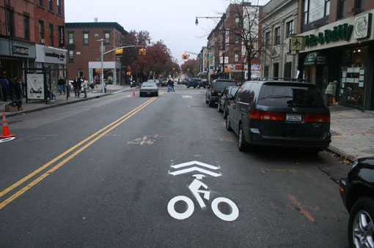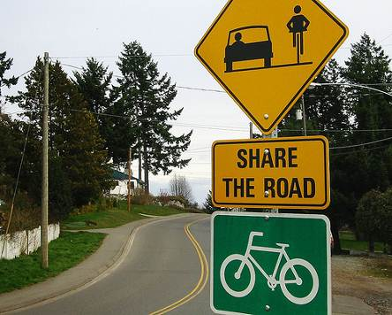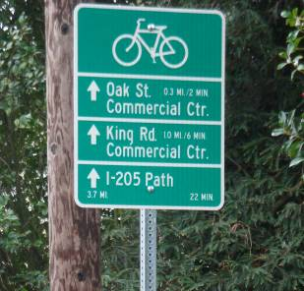

Shared Roadway for Bicycle Travel

Advantages:

1. Cost-effective and easy to implement
2. No additional pavement or street widening needed
3. Striping will help alert drivers to expect bicyclists along the route

Disadvantages:

1. May need improved street lighting in some areas, increasing utility costs
2. Less comfortable than bike lanes or shared-use paths

## Motor Vehicle Network

The downtown area of John Day has a grid-like pattern of streets, while the surrounding areas are generally disconnected and follow the natural topographic layout of the hillsides. W Main Street provides the only current motor vehicle connection from the study area to the rest of the City. Identified opportunities and needs include:

* Roadway connection from Patterson Bridge Road to Valley View Drive. The TSP and Local Street Network Plan envision a roadway connection along the existing private road alignment between Patterson Bridge Road and Valley View Drive (see Figure 8). This alignment will provide a connection between the study area and the north part of the City.

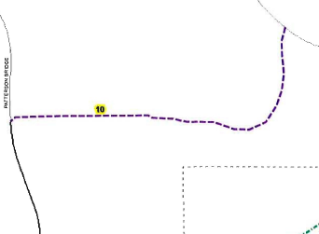

Patterson Bridge Road

Valley View Drive

Figure 8: Envisioned Roadway Connection from Patterson Bridge Road to Valley View Drive

* 7th Street Extension to Patterson Bridge Road. There is no direct east to west roadway connection on the north side of the City, with the only existing connection being W Main Street on the south side of the study area. An extension of 7th Street will provide an alternate alignment to the highway between Patterson Bridge Road and Bridge Street (see Figure 9). This will reduce reliance on the highway for travel within the City.

Figure 9: Planned 7th Street Extension

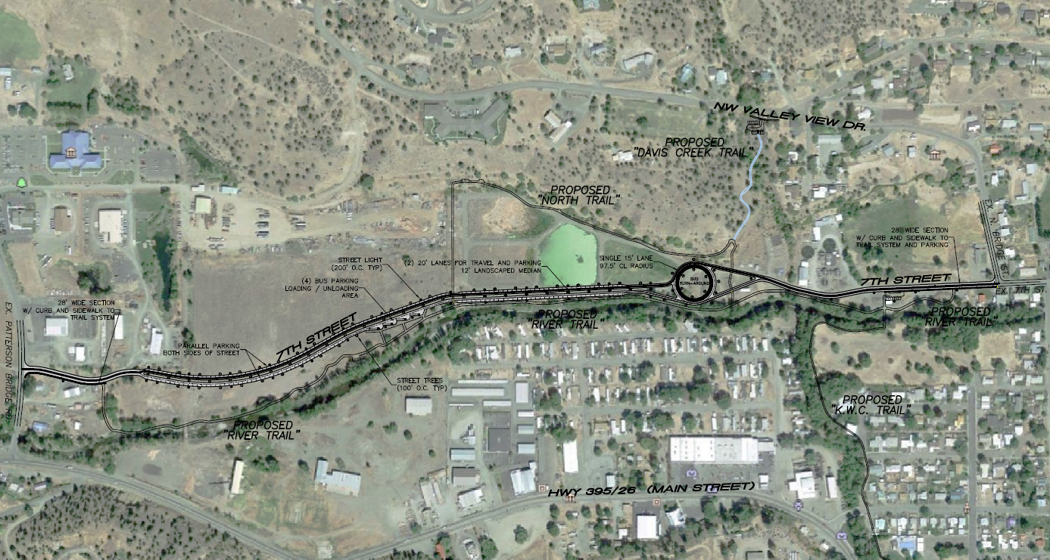

Image Source: Sisul Engineering

## Transit Network

Transit users in the John Day Innovation Gateway Area Plan study area are generally more than one mile from the closest bus stop on NE Dayton Street (greater than the typical trip length for the average walking trip). Redevelopment in the study area will attract more people and could warrant the need for an additional bus stop. While the development may set the stage for future transit, the type and extent of service improvements will play out over time. Speciﬁcs of transit service will depend on the actual rate and type of development, City and County resources and policies, and consideration of local options. The John Day Innovation Gateway Area Plan will provide walking and biking accommodations and connections that enhance the future viability of potential transit service along study area streets.

1. Analysis Procedures Manual Version 2, Oregon Department of Transportation, November 2018.
2. Based on counts obtained from the ODOT Traffic Volumes and Vehicle Classification system, Effective Date 12/31/2017.