CITY OF JOHN DAY
CITY COUNCIL MINUTES
JOHN DAY, OREGON

A recording is available on the City of John Day website for 1 year after the meeting date:
https://www.cityofjohnday.com/bc-citycouncil/page/city-council-meeting-joint-meeting-jdcc-parks-and-recreation-district-board-0

August 9th, 2022

COUNCILORS PRESENT
Ron Lundbom, Mayor
Dave Holland, Council President
Chris Labhart
Elliott Sky
Heather Rookstool
Katrina Randleas
Shannon Adair
COUNCILORS ABSENT
None

BOARD MEMBERS PRESENT
Zach Williams, Board Chair
Lisa Weigum, Budget Officer
Director, Kimberly Hernandez
Director, Rich Lallatin
Director, Russ Young
BOARD MEMBERS ABSENT
None

CITY STAFF
Interim City Manager, Corum Ketchum

GUESTS

See attached guest sheet

Remote guests

Mindy Winegar
Nada Maani I Opsis Architecture
+15415751647
A. Hofpar
Ann
Anonymous
Autumn H.
Dolores Ostberg
es
Gary & Nancy
Logan Bagett
Louis
LW

Agenda Item No. 1— JOINT MEETING OPEN AND NOTE ATTENDANCE

Start: 0:00
End 3:25

Mayor Ron Lundbom and Board Chair Zach Williams called the August 9th joint meeting of the John Day City Council and the John Day – Canyon City Parks and Recreation District to order at 7 pm.

All councilors and board members were noted present.

Agenda Item No. 2— APPEARANCE OF INTERESTED CITIZENS.

Mayor Lundbom invited members of the public to discuss items not on the Agenda.

Agenda Item No. 3- APPROVAL OF PRIOR MINUTES

None provided. Recordings are available on the City of John Day website.

Agenda Item No. 4 - Pool for All Ballot Initiative
Start: 3:25
End: 1:14:00

The Joint meeting included:
- Presentation from Opsis Architecture, the architects designing the proposed pool facility
- Joint discussion between John Day City Council and the John Day – Canyon City Parks and
Recreation District Board
- Public comment limited to 1 minute per speaker
- The opportunity for motions concerning the updated resolutions to declare the relationship and
obligations of the two entities, the management of the construction of the pool, and related projects

Nada Maani (Opsis Architecture) gave a 10-minute overview of the design and costs associated with the construction of the proposed central Grant County pool, also known as the “Pool for All” project. The costs associated with contracting the pool total approximately $6.6 million ($6,600,000 dollars). A successful passing of a bond for the project during the November ballot creates a timeline that constructs a pool center by summer 2024.

Councilor Heather Rookstool began conversation with the JD-CC Board (the Board) asking about alternatives to the proposed facility. Chair Williams responded that the Board has been exploring alternatives for five (5) years before settling on this proposal, and that he is confident that the JD-CC Parks and Recreation District could operate a facility of this size and scale. Councilor Shannon Adair, Councilor Rookstool and Director Russ Young discussed the ownership and operation of a potential pool in John Day, and the process for arriving at the proposed facility.

Board Budget Officer Lisa Weigum, Councilor Adair, and Councilor Elliot Sky discussed the size and scope of the facility. Weigum stated that facility size is dependent on several factors, including pool deck size, which is related to building square footage, which has a direct influence on the number of bathrooms and parking spaces that are required of the facility. Councilors Adair and Sky talked about sizing for the covering of the pool in the future and the inclusion of a community room, as being reasonable features for the facility. Council President Dave Holland spoke to the conversations he has had with community members, where he reiterated the need for the JD-CC Parks and Recreation District to have offices and meeting space, in comparison to the converted mobile home the District is currently using, which would be removed because of this project.

Ketchum then led a discussion of the proposed intergovernmental agreement (IGA) related to the project. He explained that per Section 3.3 of the intergovernmental agreement between the two bodies, the resolution calls for the creation of a citizen advisory committee within an ORS 190 special government, referred to as the “Joint Development Team” [AKA JD Team] to perform the following obligations for the final design and construction of the Project:

- Establish a seven-member citizen oversight committee to act as an advisory committee to the JD Team;
- Issue request for proposals (“RFP(s)”) and serve as the source selection panel to solicit for construction management, general contractor, and other professional services needed to complete the Project;
- Issue a notice of intent to award and notice of award for Project construction;
- Oversee Project construction from negotiations, approval of a general contractor, and notice to
proceed through certificate of occupancy (including, without limitation, payment of invoices,
Project financial management, and ensuring that the Project remains within budgeted funds);
- Ensure compliance with prevailing wage and other state and federal regulations and reporting
requirements;
- Hire a project manager for the Project; and
- Provide updates and information to the public concerning the Project through print and social
media sources.

Ketchum reiterated that the oversite team (JD Team) would consist of two members appointed by the John Day City Council, two members appointed by the Board and three members appointed from the public, selected by both bodies. He stated that this team is intended to give both groups a balance of authority and input over the project, while providing a platform for citizen participation and transparency. Ketchum then walked through some of the other proposals included in the IGA, including property transfers opportunities for potential partnerships between the City and the District in the future.

Director Rich Lallatin, Weigum and City Manager Ketchum discussed the capital funding of the project, where the City would expend its earmarked dollars for the project, ahead of the money the District would receive as a result of the bond. Council President Holland walked through the sources of City funding for the project, which include Kam Wah Chung related investments and proceeds from the sale of Gleason Pool, among others. Councilor Chris Labhart asked of the costs related to the bond, which Weigum responded to as being $.70 per $1,000 of assessed property valued. Labhart remarked that this was less than that of the hospital bond, which was around $1.30 per $1,000 of assessed value.

Mayor Ron Lundbom then invited public comment. 18 members of the public spoke to the project. Topics raised included: the need for a pool, the results of the last bond pool bond attempt, the average and median cost per property owner, the number of city projects moving concurrently and the need for prioritizing other necessities, including public safety.

After public comment, Mayor Lundbom invited the bodies to make any motions as a result of the discussion.

John Day City Council

Councilor Adair made a motion to pass Resolution No. 22-898-19, A Resolution of the City of John Day Reauthorizing an Intergovernmental Agreement between the City and the John Day/Canyon City Parks and Recreation District; Approving Application for Additional Grant Funds; and Related Matters, subject to legal revisions.
Seconded by Council President Holland
Passes: 6:1 with Councilor Rookstool opposing

John Day – Canyon City Parks and Recreation District Board

Board Chair Williams made a motion to pass Resolution No. 08-2022, a resolution of John Day/Canyon City Parks and Recreation District calling another measure election to submit to District’s electors the question of authorizing no more than $4,000,000.00 of general obligation bonds to finance capital costs for a pool facility; declaring District’s intent to reimburse itself with bond proceeds for qualifying pool facility related expenditures; authorizing acceptance of a Department Of Administrative Services grant for $2,000,000.00; authorizing an intergovernmental agreement between the District and City of John Day; approving application for additional grant funds; and related matters, subject to legal revisions”
Seconded by Director Lallatin
Passes: Unanimous

Councilor Adair made a motion to adjourn the joint meeting of the John Day City Council and John Day – Canyon City Parks District Board at 7:15 PM
Seconded by Council President Holland
Passes: Unanimous

Board Chair Williams made a motion to adjourn the joint meeting of the John Day City Council and John Day – Canyon City Parks District Board at 7:15 PM
Seconded by Director Lallatin
Passes: Unanimous

Agenda Item No. 5— Public Hearing For The 2022 HUD-CDBG Application For The Grant County Library

Start: 1:21:00
End 1:35:10

Mayor Ron Lundbom called the John Day City Council meeting to order at 7:21 PM.

Councilor Labhart made a motion to open a public hearing for 2022 HUD-CDBG Application For The Grant County Library
Seconded by Councilor Adair
Passes: Unanimous

Audience members were asked to sign up for public comment prior to the agenda item. No public comment was received on this application during or prior to the meeting.

City Manager Ketchum led a discussion on the HUD-CBDG application for the proposed Grant County Library. Ketchum led Council through the property transactions that have or will occur as a result of this project, and the benefits the Grant County Library is receiving as a result of this project including:
- Land located out of the flood plain, located north of the John Day River, along 7th Street and between Davis Creek Park and the existing wastewater treatment plant, which will be easier to build upon, and at a lower cost to insure for Grant County.
- Riverfront access, a walkable area, and an attractive site for patrons
- capital construction, management, and fundraising services from City staff
The City will be receiving Land for downtown parking located on NW Canton ST, while supporting a community amenity for all of Grant County ‘s residents.
John Rowell (John Day resident) informally asked about the status of the current location of the Grant County library, located on Canyon Blvd. Councilor Labhart and Ashley Armichardy (Grant County Library Foundation) led a discussion on the decisions leading up to the relocation of the proposed site for the new library. Armichardy stated that the Library Foundation, Library staff, members of the public, and elected representatives from Grant County are coordinating on a plan for the new facility. In addition, the Library Foundation will contribute $300,000 to fulfill the local matching requirements of this funding, should the request be successful.
Councilor Labhart made a motion to close the public hearing for 2022 HUD-CDBG Application For The Grant County Library
Seconded by Councilor Adair
Passes: Unanimous

Council President Holland made a motion to authorize staff to apply for $1.5 million to fund the Grant County Library construction at the proposed location.
Seconded by Councilor Adair
Passes: Unanimous

Action Item No. 6 - Consent Agenda Item – Bank of Eastern Oregon Credit Cards
Start: 1:35:15
End: 1:37:30

City Manager Ketchum explained the process for getting City staff a credit card from the Bank of Eastern Oregon. Ketchum recommended that Council authorize staff to apply for visa credit cards in the City’s name. Nicholas Green (City Contractor) recommended that Council authorize the City Manager to have a $5,000 credit limit to reflect increases in costs due to inflation, limited staff available to sign checks, and other factors.
Ketchum explained that passing the consent agenda as amended would authorize the following staff to receive credit cards:
Corum Ketchum, City Manager, $5,000 limit
Casey Myers, Public Works Director, $2,500 limit
Donald Gabbard, Fire Chief, $2,500 limit
For a total credit limit of $10,000

Councilor Sky made a motion to approve the consent agenda (granting the staff above credit cards), as amended, with the City Manager receiving a credit card with a limit of $5,000.
Seconded by Councilor Labhart
Passes: Unanimous

Action Item No. 7 - Wastewater and Water System Updates
Start: 1:37:40
End: 1:52:15

City Manager Ketchum gave the Council an update of the status of the Wastewater Treatment Plant Project to provide context for the grant that the City has been awarded to fund the “purple pipe” network of reclaimed water infrastructure. Ketchum explained the wastewater treatment plant project.

The project consists of four main components, with this grant funding component 3 in bold:
1) Build a new WRF to replace the City’s aging wastewater treatment plant;
2) Construct a Reclaimed Water Storage Tank and Pump Station to store the reclaimed water prior to beneficial re-use;
3) Install a Reclaimed Water (Purple Pipe) Distribution Network to move reclaimed water from the WRF to end users that currently used freshwater for non-potable uses;
4) Transfer City of John Day water rights instream to enhance streamflow by legally protecting these water rights for instream use.

Ketchum shared with Council the benefits the wastewater treatment plant project, the purple pipe system, and the related John Day Greenhouses. Ketchum related the Greenhouses to the City’s Community Investment Strategy (2017). The Greenhouses accomplished the following five goals:

- Demonstrate the viability of controlled environment agriculture to produce locally grown fresh food
- Provide upfront capital via grants and loans to catalyze a high-tech food production cluster in John Day
- Establish partnerships with regional growers, food outlets and distributors (CIS Focus Area 1) / Develop a plan to attract new entrepreneurs (CIS Focus Area 4)
- Identify a low-cost power source
- Generate interest in John Day from state, federal and private parties to spur investment in the City and its water system.

In addressing the operating costs of the Greenhouses, Ketchum stated that the “loss’ of $130,000 for the two years during COVID net the City $5.87 million in total value through these grants. The City has also agreed to lease the facility to an entrepreneur for the cost of its capital loan on the property, making the project revenue neutral, and a catalyst for private sector growth.

Ketchum then introduced the purple pipe project, and reclaimed water from the new wastewater treatment plant. John Rowell, John Day Resident, asked about the uses of the reclaimed water. Ketchum and Council responded that Class A drinking water (the standard being used by the new treatment plant) can be used for everything but direct human consumption in the state of Oregon, including industrial and agricultural uses (e.g., human food crops consumed raw).

Councilor Rookstool asked if community partners and businesses have been contacted about receiving purple pipe water. Staff and Mayor Lundbom responded that the key institutions, including the John Day Golf Course, Malheur Lumber and Iron Triangle LLC have been notified.

Ketchum showed the Council an overview of the tasks associated with the wastewater treatment plant, and associated tasks. Ketchum stated that all these tasks have received or are pending funding, which are given below.

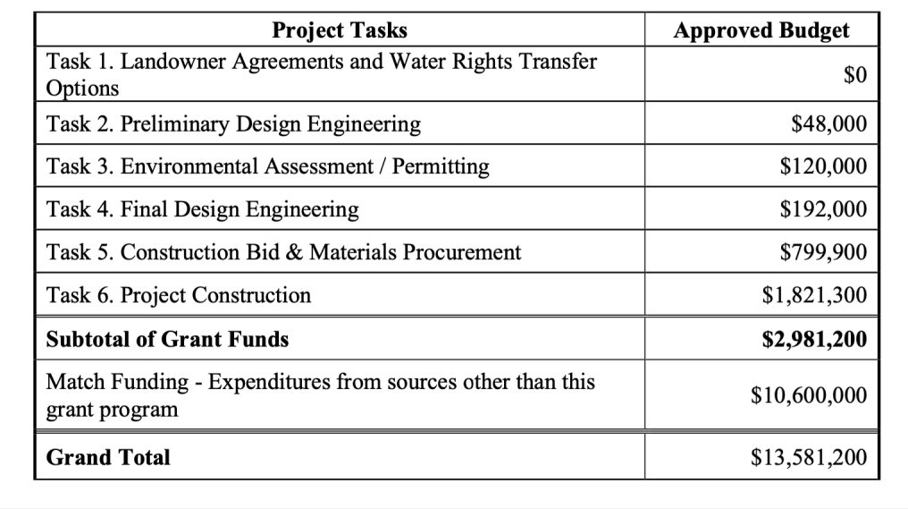

Ketchum invited Council to approve a motion to receive the grant funding. Councilor Rookstool asked if the funding application needed to list the current City Manager, since the agreement predated personnel change. Ketchum responded that it wasn’t likely to be an issue.

Rowell asked if the match funding was readily available. Green responded that the money is related to a USDA grant, which requires a biological assessment to be submitted on behalf of the river. That assessment has been completed and will be submitted.

Sherrie Rininger (John Day) asked where she could receive information about the gross operating costs of the wastewater treatment plant. Mayor Lundbom responded that staff could get her that information by the next meeting.

Councilor Labhart made a motion to approve staff and the mayor to sign the grant agreement and receive the funding as outlined in the agreement ‘WPG-0034-21 John Day Innovation Gateway Adaptive Water Reuse
Seconded by Councilor Sky
Passes: Unanimous

Action Item No. Other Business and Upcoming Meetings
Start: 1:52:15
End: 2:10:45

Mayor Lundbom in response to questions from prior meetings regarding the use of ARPA funds for utility relief, stated that per the rules of the program, that funding could not be spent on utilities. Councilor Rookstool read aloud specific language barring the use of ARPA funds for utility reimbursements.

    - Children in the Office
Ketchum gave a synopsis of his call with the City’s insurance company regarding having children in the workplace. Councilor Sky gave an overview of the Grant County Childcare Study (2022) and project next steps. Councilor Randleas is also involved in that work.

    - Facades Program
Ketchum stated he received the final agreement from the City’s attorney and will outreach to businesses.

    - Operating Rules Ordinance
Ketchum stated that he is working with the City Attorney to draft a new ordinance to run public meetings more smoothly.

    - iv. Pit Stop Updates
Ketchum gave an overview of the current construction status of the Pitstop. Councilor Labhart inquired about alcohol at the site. Ketchum stated that is among the options staff are exploring. Councilor Adair responded that the results of a previous survey of downtown business owner indicated interest in expanding the offerings at the site.

Councilor Rookstool made a call for volunteers for the Grant County Fair.

Councilor Labhart thanked the public for their participation, and for keeping their comments civil and brief.
Upcoming meetings
- August 23rd, 2022 | City Council Meeting – Fire Hall, 7:00 PM
- September 13th, 2022 | City Council Meeting – Fire Hall, 7:00 PM
- September 27th, 2022 | City Council Meeting – Fire Hall, 7:00 PM

Mayor Lundbom stated he would not be available for the September 27th meeting.

ADJOURN

Start: 2:10:45
End: End of recording

Council President Holland made a motion to adjourn the August 9th, 2022, John Day City Council Meeting at 8:10 PM
Seconded by Councilor Adair
Passes: Unanimous

Respectfully Submitted:

Corum Ketchum, Interim City Manager

ACCEPTED BY THE CITY COUNCIL ON August 23, 2022.

_____________________________
Ron Lundbom, Mayor

